Racing to English  Activity 3e | Face and head | Picture  Dictionary

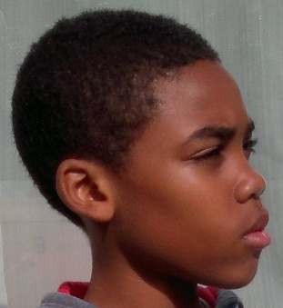  a head  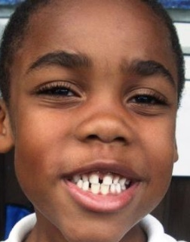  a face  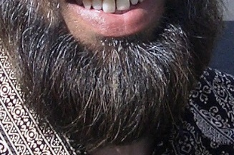  a beard  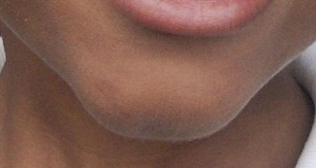  a chin  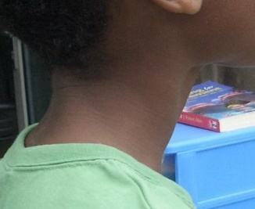  a neck | 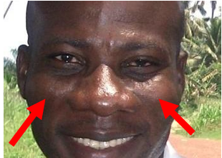cheeks  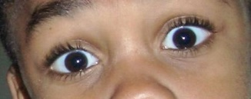  eyes  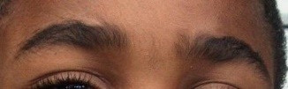  eyebrows  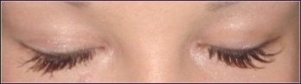  eyelashes  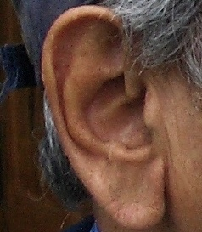  an ear  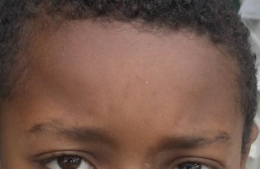  a forehead  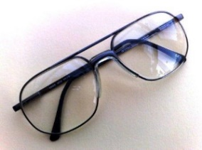  a pair of glasses | 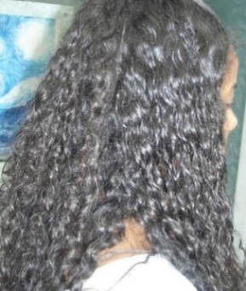  hair  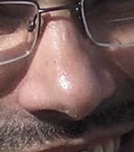  a nose  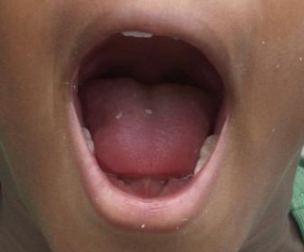  a mouth  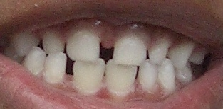  teeth  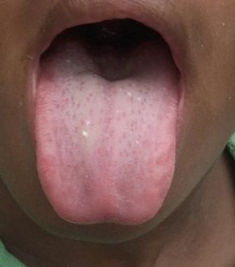  a tongue

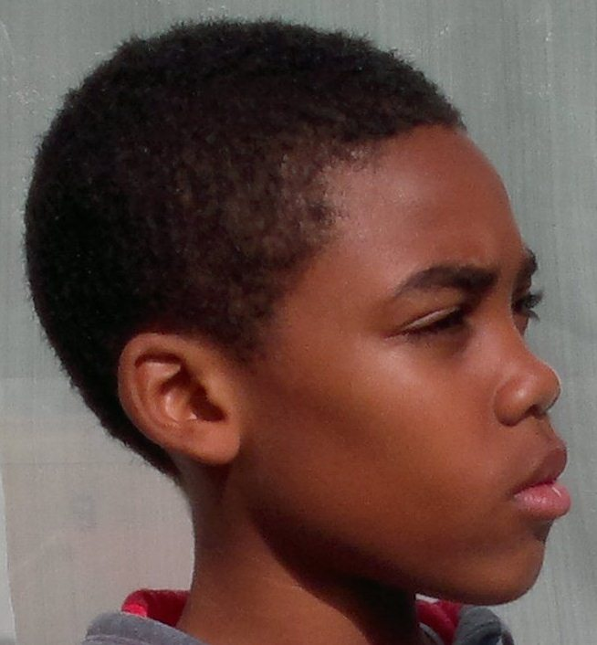 | a head
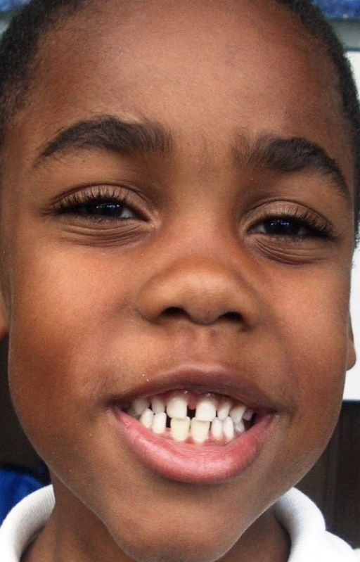 | a face
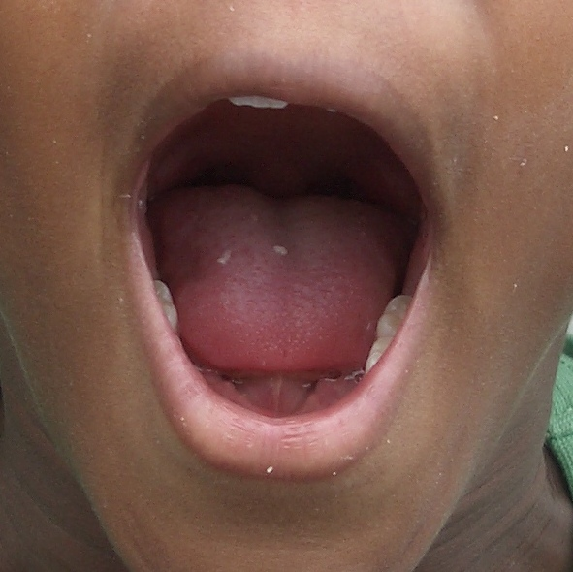 | a mouth
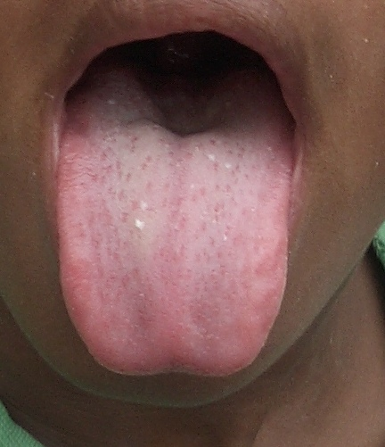 | a tongue
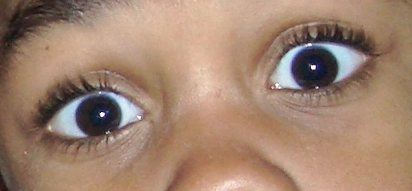 | eyes
 | teeth
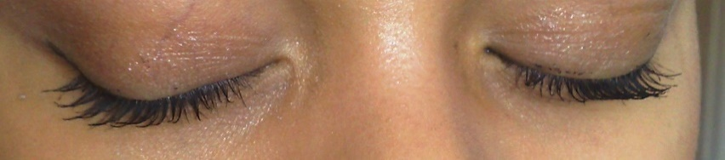 | eyelashes
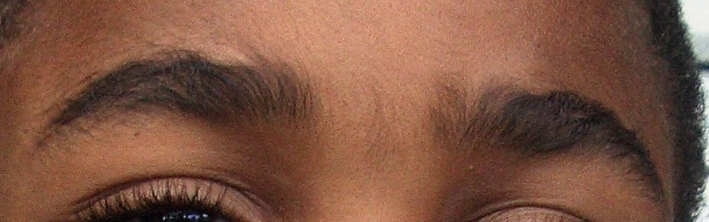 | eyebrows
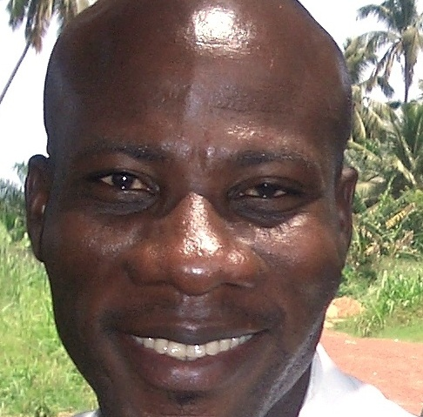 | cheeks
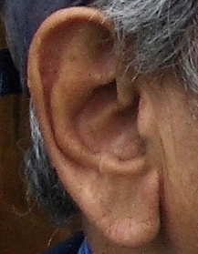 | an ear
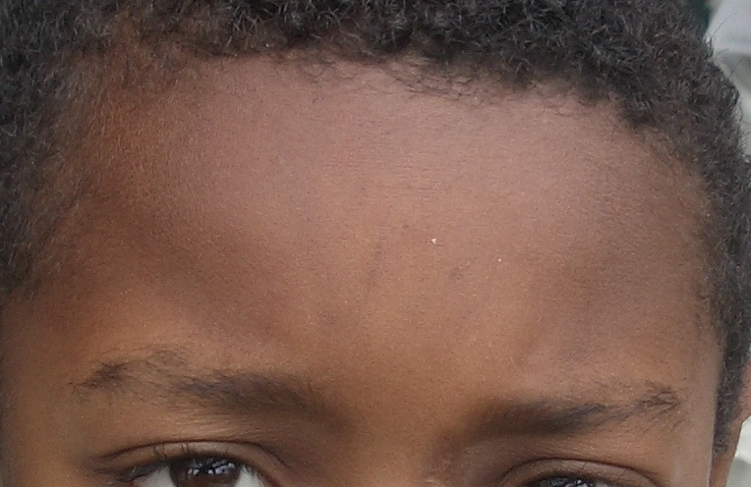 | a forehead
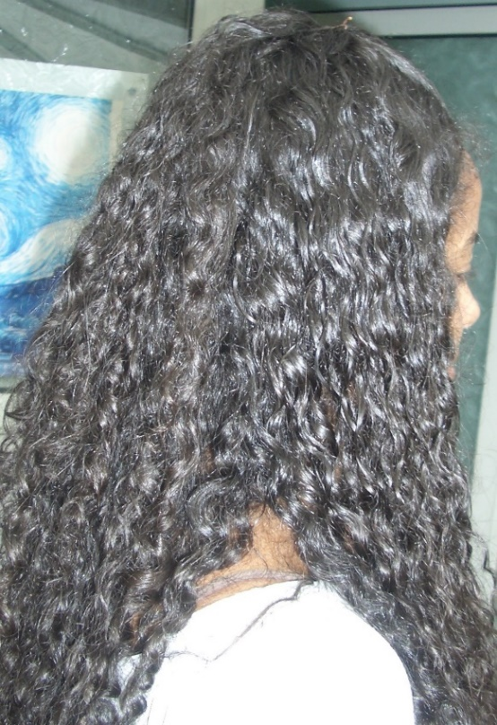 | hair
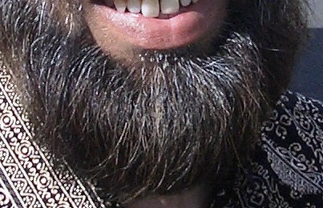 | a beard
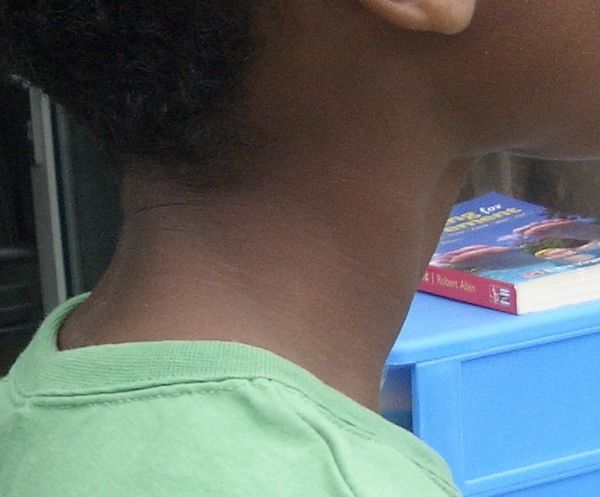 | a neck
 | a nose
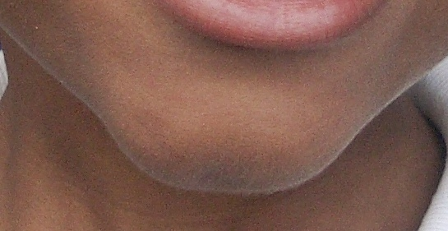 | a chin
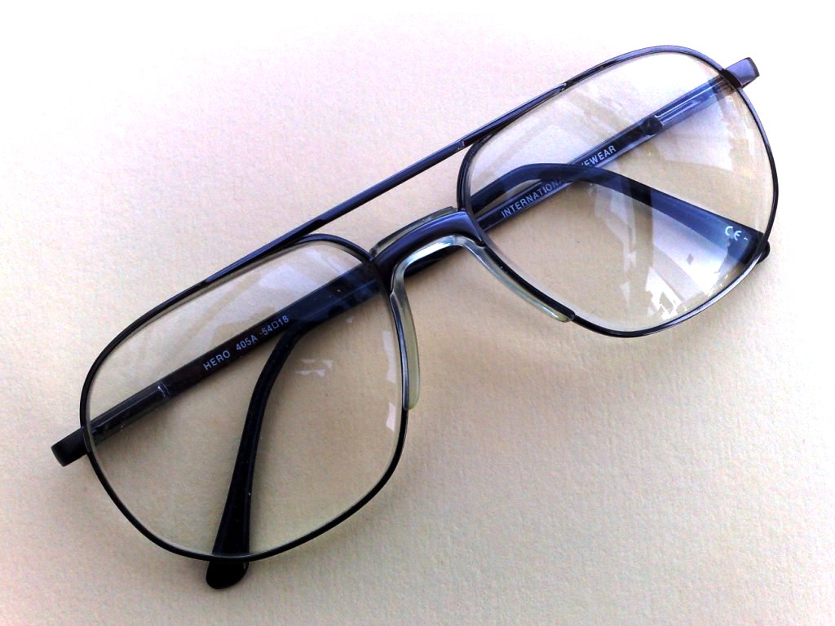 | a pair of glasses

Racing to English  Activity 3e | Face and head | Worksheet 1  copy work

e |  | ear  ear | ______  ______
ch | 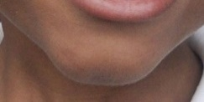 | chin  chin | ______  ______
ch |  | cheeks  cheeks | ______  ______
t | 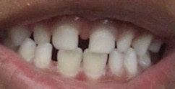 | teeth  teeth | ______  ______
n |  | nose  nose | ______  ______
m | 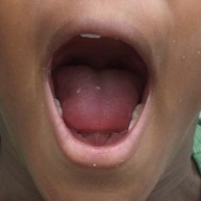 | mouth mouth | ______  ______
Instructions: Write over the yellow words. Copy the words on to the lines.

Racing to English  Activity 3e | Face and head | Worksheet 2  wordsearch

Draw the lines
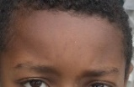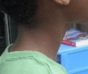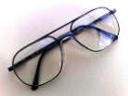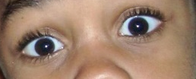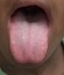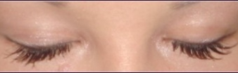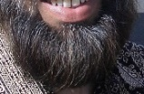
glasses neck beard tongue forehead tongue eyes eyelashes

Translate these words into your first language
English | First language: |  | English | First language:
eyes |  |  | chin
eyelashes |  |  | cheek
glasses |  |  | beard
teeth |  |  | neck
tongue |  |  | forehead

Now find these words in the wordsearch:
an  beard  cheek  chin  eye  eyelashes  forehead  glasses  mouth  neck  teeth  tongue | e | t | o | n | g | u | e
 | y | g | e | b | m | t | f
 | e | l | y | e | o | e | o
 | l | a | e | a | u | e | r
 | a | s | a | r | t | t | e
 | s | s | n | d | h | h | h
 | h | e | n | e | c | k | e
 | e | s | c | h | i | n | a
 | s | c | h | e | e | k | d

Racing to English  Activity 3e | Face and head | Worksheet 3

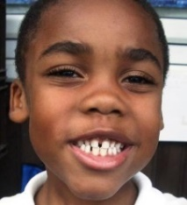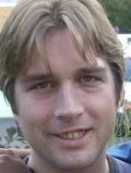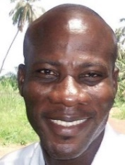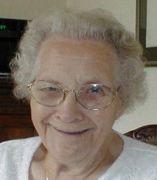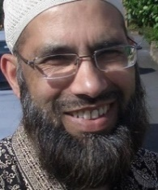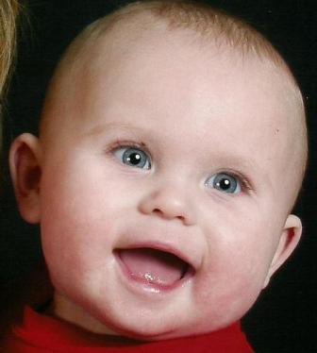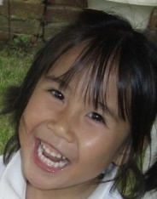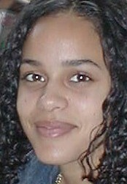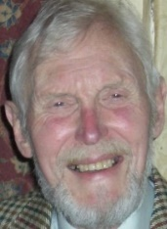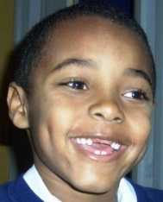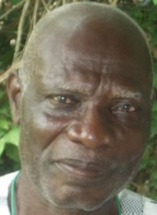
Look at the photos.
Ask your friend some questions:
How many | faces  ears  mouths  beards  eyes  eyebrows  pairs of glasses | can you see?
Now write 10 questions and answer them.

Write 6 sentences: Write 10 sentences:
I’ve got  I haven’t got | a | beard.  chin.  forehead.  mouth.  nose.  neck. |  | I’ve got  I haven’t got | two  lots of | teeth.  eyebrows.  eyelashes.  eyes.  ears.  cheeks.

