|  |  |  |
| --- | --- | --- |
| **Racing to English**  **Activity 9f** | **Billy, Milly, Maisy and Bob** | **Intro** |

|  |  |  |  |
| --- | --- | --- | --- |
| **Billy** | **Milly** | **Maisy** | **Bob** |
|  |  |  |  |

**64**

Billy, Milly, Maisy and Bob were friends.

They lived together.

They lived in house number 64 .

|  |  |
| --- | --- |
|  | This is a pizza. |

|  |  |  |
| --- | --- | --- |
| **Racing to English**  **Activity 9f** | **Billy, Milly, Maisy and Bob** | **1** |

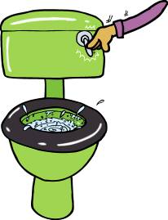Billy, Milly, Maisy and Bob were friends. They lived together.

One day Maisy said, “The toilet is dirty. Bob, please will you clean the toilet?”

“No,” said Bob, “I want to play football.”

So Bob went and played football.

And Maisy cleaned the toilet.

Then Maisy looked in the fridge. There was no food in the fridge.

Maisy said, “There’s no food in the fridge. Milly, please will you go to the supermarket and buy some food?”

“No,” said Milly, “I want to go to town and buy some clothes.”

So Milly went to town and bought some clothes.

And Maisy went to the supermarket and bought some food.

Then Maisy said, “Billy, please will you cook the food?”

“No,” said Billy, “I want to ride my motorbike.”

So Billy rode his motorbike.

And Maisy cooked the food.

Ask your friend some questions:

|  |  |  |  |
| --- | --- | --- | --- |
| Did | Billy  Milly  Maisy  Bob | play football?  clean the toilet?  go to the supermarket?  go to town?  buy some clothes?  buy some food?  cook the food?  ride a motorbike? |  |

Answers:

|  |  |  |
| --- | --- | --- |
| Yes | he  she | did. |
| No | he  she | didn’t. | Billy  Milly  Maisy  Bob | played football.  cleaned the toilet.  went to the supermarket.  went to town.  bought some clothes.  What do you think happened next?  bought some food.  cooked the food.  rode a motorbike. |

Now write ten questions and answers.

|  |  |  |
| --- | --- | --- |
| **Racing to English**  **Activity 9f** | **Billy, Milly, Maisy and Bob** | **2** |

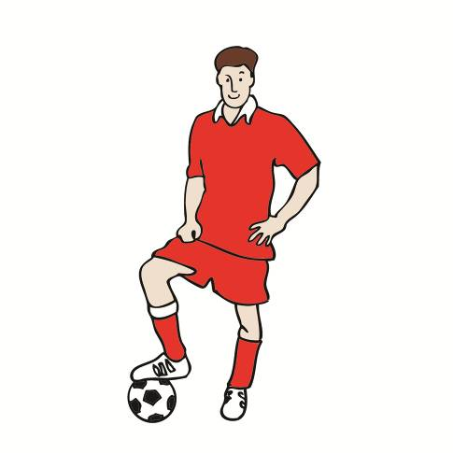

Maisy cooked a pizza.

Bob came home from football.

“I’m hungry,” he said. “Can I have some of your pizza?”

“No,” said Maisy. “You didn’t clean the toilet!”

Milly came home from town.

“I’m hungry,” she said. “Can I have some of your pizza?”

“No,” said Maisy. “You didn't go to the supermarket and   
you didn’t buy the food!”

Billy came home from riding his motorbike.

“I’m hungry,” he said. “Can I have some of your pizza?”

“No,” said Maisy. “You didn’t cook the food!”



Maisy took the pizza to her room, she watched television   
and she ate the pizza. She was happy!

Read this to your friend then write it.

Bob didn’t clean the toilet, he played football.

Milly _______________ to the supermarket, she _______________ to town.

Milly _______________ the food, she _______________ some clothes.

Billy _______________ the food, he _______________ his motorbike.

Maisy _______________ football, she _______________ the toilet.

Maisy _______________ to town, she ______________ to the supermarket.

Maisy _______________ some clothes, she _______________ some food.

Maisy _______________ her motorbike, she _______________ pizza.

|  |  |  |  |
| --- | --- | --- | --- |
| didn’t | buy  bought  clean  cleaned | cook  cooked  go  went | play  played  ride  rode |

What do you think happened next?

|  |  |  |
| --- | --- | --- |
| **Racing to English**  **Activity 9f** | **Billy, Milly, Maisy and Bob** | **3** |

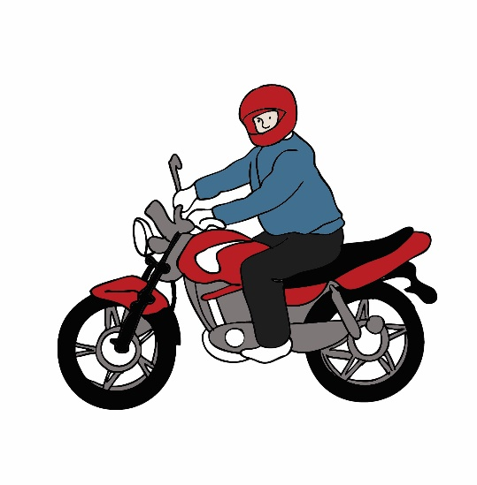“I’m hungry,” said Milly.

“I’m very hungry,” said Billy.

“I’m very, very hungry,” said Bob.

Bob said, “Billy go to the supermarket on your motorbike   
and buy three pizzas.”

So Billy went to the supermarket and bought three pizzas.

Bob said, “Milly go to the kitchen and cook the pizzas.”

So Milly went to the kitchen and cooked the pizzas.

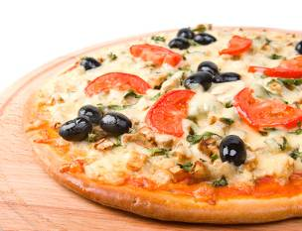Then Milly and Billy and Bob ate the three pizzas.

“That was good,” said Bob. “Now I want to watch television.”

“No,” said Milly and Billy. “You didn’t go to the supermarket, you didn’t buy the pizzas, you didn’t cook the pizzas. Go to the kitchen and wash the dishes!”

So Bob went to the kitchen and washed the dishes. He was not happy!

Look at this:

**She cooked a pizza. 🡺 Did she cook a pizza?**

Read these to your friend and change them into questions.

1. She looked in the fridge. **🡺**
2. He rode his motorbike. **🡺**
3. She bought some food. **🡺**
4. He played football. **🡺**
5. She cleaned the toilet. **🡺**
6. He washed the dishes. **🡺**
7. She went to town. **🡺**
8. She took the pizza to her room. **🡺**
9. She watched television. **🡺**
10. They ate the pizzas. **🡺**

Now write the questions.