Racing to English  Activity 11d | Sorry about hot water  by Waheed

Read the story with your friend.

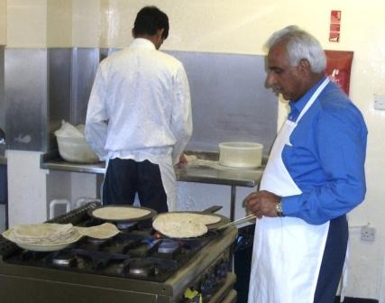 | When I was 11 years old, I lived in Pakistan.  One day, some men cooked some food in my school.  They threw some hot water out of the window.
I was outside the school. I was walking past the window. The hot water went on my face. It hurt me.
I went home and I told my uncle.
He came to the school and he talked to the men.
He said, “Can you see you have hurt his face?”
They said they were very sorry. They said it was an accident.

Can you read these words?
hurt | past | window | hot | water
outside | accident | threw | face | home
uncle | school | sorry | cooked | talked

Can you either translate the words into another language
or write some sentences using each of the words.

Racing to English  Activity 11d | Sorry about hot water  by Waheed | Worksheet 1

Ask your friend some questions:
Yes No
1. Did some men cook some food?
2. Did the men cook some windows?
3. Did they throw the food out of the window?
4. Did they throw some hot water out of the window?
5. Did the hot water hurt the men?
6. Did it hurt Waheed’s uncle?
7. Did it hurt Waheed's face?

Yes I have. No I haven't.
8. Have you ever cooked some food?
9. Have you ever cooked some food in school?
10. Have you ever thrown something out of a window?
11. Have you ever hurt your face?
12. Have you ever been very sorry?

Please use long answers for the next questions:
- Where did Waheed live?
- How old was Waheed?
- Where did the men cook the food?
- Where did Waheed walk?
- What did the men throw?
- What did the water do to Waheed?
- Why did Waheed's uncle go to school?
- What did the men say?

Now write the questions and the answers.

Racing to English  Activity 11d | Sorry about hot water  by Waheed | Worksheet 2

Now do some of these things:
Draw a picture of someone cooking.
Write a story about cooking.
Write a story about an accident in a kitchen.
Make a wordsearch for your story.
You can write the story in English or in your first language.

Find these words in the wordsearch:
accident  cooked  face  home  hot  hurt  I  outside | past  school  sorry  talked  threw  uncle  water  window | o | w | c | o | o | k | e | d | s
 |  | u | i | s | c | h | o | o | l | o
 |  | t | n | h | t | h | r | e | w | r
 |  | s | d | o | u | n | c | l | e | r
 |  | i | o | m | f | a | c | e | p | y
 |  | d | w | e | h | u | r | t | a | h
 |  | e | t | a | l | k | e | d | s | o
 |  | w | a | t | e | r | m | y | t | t
 |  | I | a | c | c | i | d | e | n | t

Now write 7 questions about the story. Write questions that you do NOT know the answer to.
For example What food did the men cook?
What day was it?
Now rewrite the story but make it longer so that it has got the answers to your questions in it.

Cut out these story strips and work with your friend to put them in the right order:

When I was 11 years old, I lived in Pakistan.
One day, some men cooked some food in my school.
He said, “Can you see you have hurt his face?”
They said they were very sorry.
They said it was an accident.
They threw some hot water out of the window. I was outside the school.
Sorry about hot water
by Waheed
I was walking past the window. The hot water went on my face. It hurt me.
I went home and I told my uncle. He came to the school and he talked to the men.

