Racing to English  Activity 16c | Disappointed at a football match  by Khalid

Read the story with your friend.
One day, when I was in Pakistan, I went to watch a football match with my grandfather. We saw my uncle on his motorbike. |  | 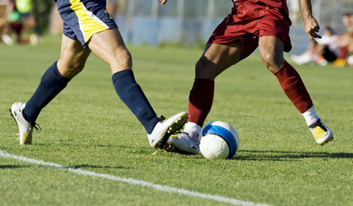
My grandfather said, “Stop your uncle and ask him to come and watch the football with us.”
I stood in the middle of the road and I put out my arms. But my uncle didn’t stop. The motorbike crashed into me.
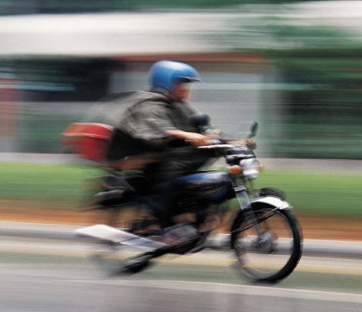 | A man in a lorry took me to hospital.  The doctor put eight stitches in my head. My head was very painful and I was disappointed that I didn’t see the football match.

Can you read these words?
football | uncle | middle | crashed | doctor
match | watch | motorbike | lorry | stitches
grandfather | stood | arms | hospital | head
Can you either translate the words into another language
or write some sentences using each of the words.

Racing to English  Activity 16c | Disappointed at a football match  by Khalid | Worksheet 1

Ask your friend some questions
Yes No
- Did Khalid watch a football match with his uncle?
- Did he watch it with his grandfather?
- Did his grandfather ride a motorbike?
- Did Khalid stand in the middle of the road?
- Did he put out his arms?
- Did his uncle stop?
- Did a man in a lorry take his uncle to hospital?

Yes I have. No I haven't.
- Have you ever seen a football match?
- Have you ever seen your uncle on a motorbike?
- Have you ever stood in the middle of the road?
- Have you ever said “Stop”?
- Have you ever been knocked down by a motorbike?

Please use long answers for the next questions:
- Who went to watch a football match with Khalid?
- Who was riding a motorbike?
- What did Khalid’s grandfather want his uncle to do?
- Who stood in the middle of the road?
- Why did Khalid put his arms out?
- What crashed into Khalid?
- Who took Khalid to hospital?
- What did the doctor do?

Racing to English  Activity 16c | Disappointed at a football match  by Khalid | Worksheet 2

Now do some of these things:
- Draw a picture of a motorbike.
- Write a story about a football game.
- Write a story about a motorbike.
- Make a wordsearch for your story.
You can write the story in English or in your first language.

Find the words in the wordsearch:
arm  crashed  disappointed  doctor  football  grandfather  hospital  match  motorbike | middle  Pakistan  stitches  stood  uncle  watch  we | c | m | o | t | o | r | b | i | k | e | m | P
 |  | r | d | s | t | i | t | c | h | e | s | a | a
 |  | a | o | w | m | i | d | d | l | e | a | t | k
 |  | s | c | a | u | n | c | l | e | w | r | c | i
 |  | h | t | t | s | t | o | o | d | e | m | h | s
 |  | e | o | c | f | o | o | t | b | a | l | l | t
 |  | d | r | h | h | o | s | p | i | t | a | l | a
 |  | g | r | a | n | d | f | a | t | h | e | r | n
 |  | d | i | s | a | p | p | o | i | n | t | e | d

Now write 7 questions about the story. Write questions that you do NOT know the answer to.
For example: Where was the football match?
Why didn’t Khalid’s uncle stop?
Now rewrite the story but make it longer so that it has got the answers to your questions in it.
Cut out these story strips and work with your friend to put them in the right order:

ask him to come and watch the football with us.” I stood in the middle of the road and
One day, when I was in Pakistan, I went to watch a football match with my grandfather.
The doctor put eight stitches in my head. My head was very painful, and I was disappointed that I didn’t see the football match.
Disappointed at a football match
by Khalid
I put out my arms. But my uncle didn't stop.
The motorbike crashed into me.
A man in a lorry took me to hospital.
We saw my uncle on his motorbike. My grandfather said, “Stop your uncle and

