Racing to English  Activity 18c | Preposition picture pairs | Picture  Dictionary

towards
away from
in front of
behind

on | in | under | between

They are running towards the tree.
They are running towards the tree.
They are running away from the tree.
They are running towards the house.
They are running away from the house.
They are running away from the house.
They are sitting in front of the house.
They are standing behind the house.
They are standing behind the table.
They are standing in front of the table.
They are sitting in front of the tree.
They are sitting behind the tree.

Racing to English  Activity 18c | Preposition picture pairs | Worksheet

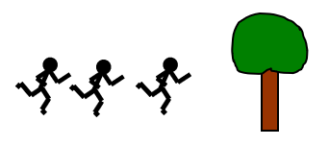
1 | 2 | 3 | 4

Ask your friend some questions:
In picture | 1  2  3  4  5  6  7  8 | are  is | the men  the man | running  sitting | away from  behind  between  in  in front of  on  towards  under | the tree?  the table?  the box?  the boxes?
Now write 10 questions and answer them.

5 | 6 | 7 | 8

