Racing to English  Activity 31b | Lenny Henry |  |  | True stories
Lenny Henry is a comedian. He makes people laugh.  When he was a child he lived in Dudley which is about ten miles from Birmingham.  When Lenny was 16, there was a programme on television called New Faces. It was a talent show. Many singers and comedians tried to get on the show.  One day, Lenny didn’t go to school. He went to Birmingham. He went to audition for New Faces. He didn’t get home till seven o’clock. His mother was very worried about him.  ‘WHERE HAVE YOU BEEN?’ she shouted. |  |  | 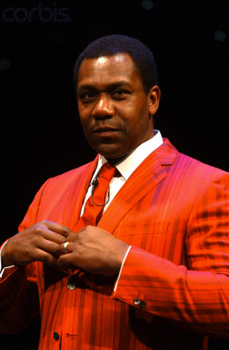
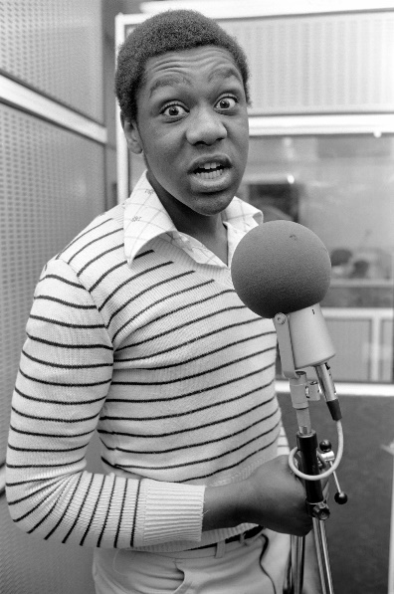  Lenny when he was 16 |  | Lenny had not told her that he was going to miss school.  He had not told her that he was going to an audition.  He had not told her that he wanted to be a comedian.  Lenny had performed for his friends at school. He had mimicked many people and he had made his friends laugh. But his mother had never seen him performing. She had never seen him making people laugh. She had never seen him telling jokes or mimicking other people.  That evening, Lenny told her what he had done.  He performed his act for her. She was amazed.
Of course, Lenny passed the audition. He went on to the show on television and he won the show. He is now one of Britain’s favourite comedians.

Ask your friend some questions.

When he first auditioned for the talent show, |  |  | Yes he had.  No he hadn’t
had Lenny | told his mother he was going to miss school?  performed for his friends?  made his friends laugh?  performed for his mother?  made his mother laugh?  travelled to Birmingham? | .

Look at the story about Lenny.
Now write about yourself. Write about something that you had not done.

Racing to English  Activity 31b | Lenny Henry | Worksheet
Look at this passage with some friends. Decide which words fit in each space:

Lenny Henry is a __________1__________. He makes people laugh. In 1975, there was a programme on television called New Faces. It was a __________2________ show.
Lenny was 16. One day, he didn’t go to school. He went to Birmingham. He went to audition for New Faces. He didn’t get home till seven o’clock. His mother was very __________3__________ about him. ‘WHERE HAVE YOU BEEN?’ she shouted.
Lenny had not told her that he was going to __________4__________ school. He had not told her that he was going to an __________5__________. He had not told her that he wanted to be a __________6__________.
Lenny had _________7_______ for his friends at school. He had _________8_________ many people and he had made his friends laugh. But his mother had never seen him __________9__________. She had never seen him making people laugh. She had never seen him telling jokes or __________10__________ other people.
That evening, Lenny told her what he had done. He __________11__________ his act for her. She was amazed.
Of course Lenny passed the _________12_________. He went on television and he won the show. He is now one of Britain’s ___________13___________comedians.
audition  audition  comedian  comedian | favourite  mimicked  mimicking  miss | performed  performed  performing | talent  worried

Racing to English  Activity 31b | Lenny Henry – Dictionary page | True stories

Word | Definition | Translation
an act | a performance
amazed | Very, very surprised
audition | a short performance that an actor, musician, dancer, etc. gives to show what they can do
comedian | a person whose job is to make people laugh by telling jokes and funny stories etc.
favourite | the thing you like best
joke | a funny story that makes people laugh
mimic | copy the way in which someone speaks in order to make people laugh
miss school | not to go to school
perform | to make people happy by singing, dancing, telling jokes, etc.
shout | speak very loudly
talent | being very good at something;  the ability to do something very well
worried | thinking that something bad has happened

cut out these cards then work with a friend to match them.
an act | a performance
amazed | very, very surprised
audition | a short performance that an actor, musician, dancer, etc. gives to show what they can do
comedian | a person whose job is to make people laugh by telling jokes and funny stories etc.
favourite | the thing you like best
joke | a funny story that makes people laugh
mimic | copy the way in which someone speaks in order to make people laugh
miss school | not to go to school
perform | to make people happy by singing, dancing, telling jokes, etc.
shouted | speak very loudly
talent | being very good at something; the ability to do something very well
worried | thinking that something bad has happened

