Racing to English  Activity 41a | Bell tower | News

HEADLINE:
Italian locals angry after tourists
stop the bells that helps them sleep

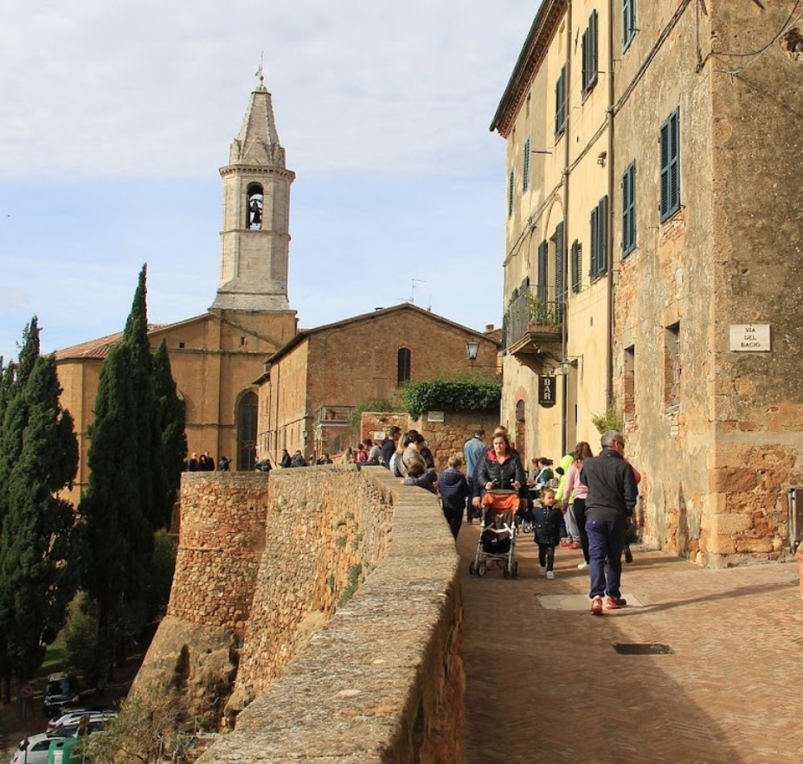  This photo was taken in Pienza a town in Italy. Can you see the bell tower? | Locals in an Italian town have complained that they cannot sleep after the bells of their historic tower were silenced at tourists’ request.  The bells used to ring every 30 minutes. But after many complaints from visitors that the bells were keeping them awake, the decision was taken to silence them between 10pm and 7am.  The complaints came from foreign guests staying in B&Bs, particularly in the summer, when they were more likely to leave windows open overnight to keep their rooms cool.

However, although the move has made the tourists happy, not all local residents are happy with the decision. Some local residents have complained that they cannot sleep without the regular sound of the bells that they have been accustomed to hearing all their lives.
The mayor of the town has defended the decision, saying: “We are not the only ones to do this. Other towns that have bell towers have done just the same thing.”

Do some of these exercises. Work with a friend if possible.

- Translate the news story into your first language or another language.
- Think about the place where you live, is there something you would like to change about it? What is it? Why do you want to change it?
- After reading the story who do you think is right the tourists or the locals? Was the mayor right to silence the bells during the night?
- Write definitions for these words:
locals | tourists | complain | historic
silenced | foreign | B&Bs | residents
regular | tolling | accustomed | defended

