Racing to English  Activity 41d | Mt Etna erupts | News

Headline (August 2023)
Mount Etna volcanic eruption forces Sicily’s main airport to close

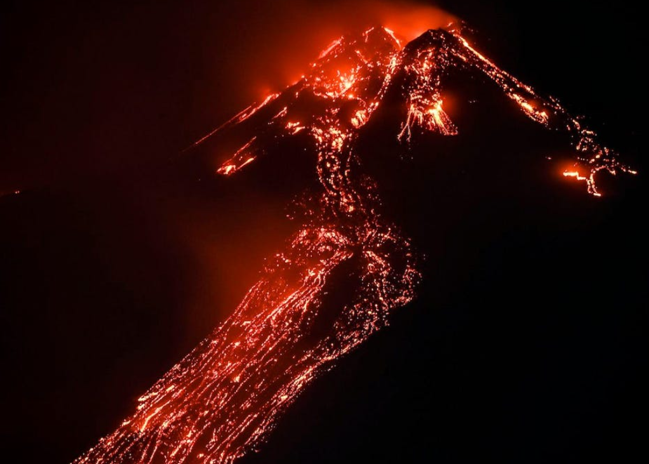 | Mount Etna, a volcano in Sicily, erupted in 2023.  Catania Airport (Sicily’s busiest airport) is about 50km south of Etna and the flight of tens of thousands of travellers due to fly to or from the airport, were diverted or cancelled due to the eruption of Etna.  Several airlines were affected by the closure of the airport.

Seven Ryanair flights were due to land at Catania, but they were diverted to another airport at the far west of Sicily. The carrier told travellers: “Due to the eruption of Mount Etna, we would like to advise all passengers traveling to and from Catania on 14 August of possible delays, diversion or cancellations to flights. Affected passengers will be notified as soon as possible. Ryanair understands the disruptions to passengers resulting from delays, diversions, or cancellations; the situation is unfortunately outside of our control, and we thank you for your patience.”

The EasyJet spokesperson said: “We are providing customers affected by the cancellations with options to transfer to another flight for free or to receive a refund. We are also providing hotel accommodation and meals for those who require it.”

Under European air passengers’ rights rules, travellers whose flights are heavily delayed or cancelled are entitled to hotels and meals as appropriate – and to be taken to their destination as soon as possible.

Do some of these exercises. Work with a friend if possible.

- Translate the news story into your first language or another language.
- Do you know about any other eruptions. Write the story of one of them
- Have you ever had a problem when travelling? What happened?
- Write definitions for these words:
volcano | erupted | diverted | cancelled
due to land | carrier | delay | providing
options | transfer | refund | destination
Are there any other words you find difficult?

