Racing to English  Activity 41e | Storms in France | News

Headline (August 2023)
Winter storms in August have destroyed half of this French farmer’s crops

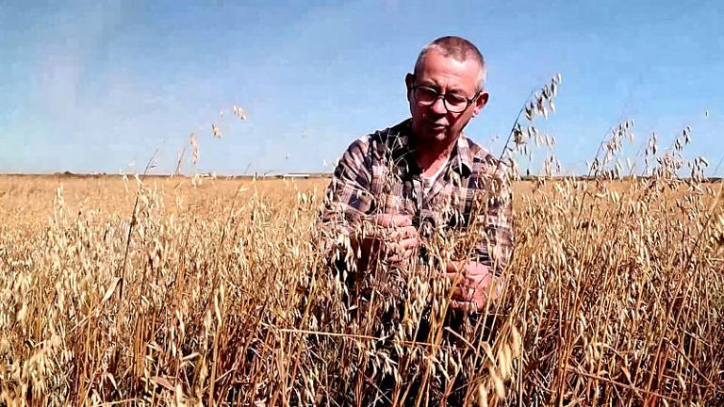 | Weeks of rainy weather followed by a big storm in early August have destroyed crops in northern France. Bertrand (the farmer in the photo) lost half of his oat crops to unseasonable weather.  "We've never seen anything like it," he said. "We had a winter storm in the middle of summer."

Northern France saw gusts of up to 80 kilometres per hour and heavy rains in recent weeks during a stormy episode. While Bertrand usually harvests around 3.2 tonnes of oats a year, he expects to harvest less than a tonne this season due to the unusual weather.
“My area saw double the usual amount of rain between September and March and the fields were flooded,” Bertrand said.
As a cattle breeder, Bertrand uses 50 per cent of his oat production to feed his cows. He usually sells the other half, which provides him with additional income. This year, he barely has enough to feed his animals. He hopes to be able to benefit from government aid and crop insurance to compensate for his losses.

The United Nations's weather agency has warned that the number of extreme weather events has increased nearly fivefold from the 1970s due to global warming.

Do some of these exercises. Work with a friend if possible.

- Translate the news story into your first language or another language.
- What other things are happening because of global warming?
- What do you think Bertrand and other farmers can do about the change in the climate?
- Write definitions for these words:
storm | crop | unseasonable | gust
tonne | expect | harvest | season
cattle breeder | production | additional income | benefit

Are there any other words you find difficult?

