Racing to English  Activity 20a | Guess which person  Teachers’ notes

Language Learning Focus
Language functions | Describing people
Sentence structures | - Has she got grey hair?  - Is he wearing glasses?

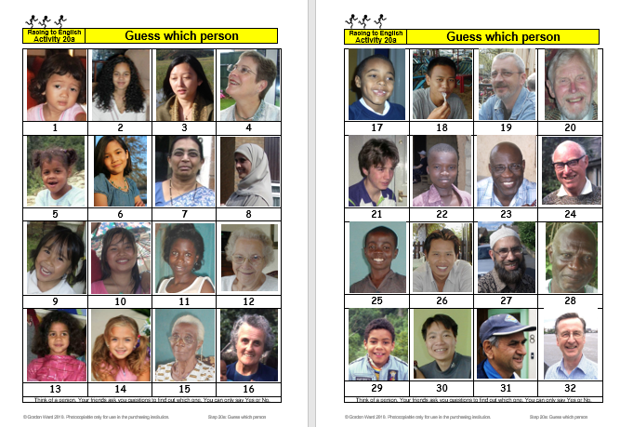 | CONTENTS  - Two sheets each with 16 photographs of people – one sheet has 16 men, the other 16 women  - Three worksheets for oral and written work  PREPARATION  - Print out enough copies of the picture pages so that there is at least one copy between two learners and one for you.  - Cut up one set to make individual small cards (this is optional, and is not usually necessary for older learners).

METHOD
This activity is very similar to the game ‘Guess Who’.

- Give out enough copies of the picture sheets so that everyone can easily see them (each person having their own copy is ideal).
- Take one of the small cards (if you are using them - otherwise simply think of one of the people).
- Tell the learners to look at the board with all the people on it and to ask Yes/No questions to work out which card you are holding, for example Is it a woman? Is she black? Is she wearing a hat? etc.
- The learner who guesses which person/object it is wins the small card. The winner is the player with the largest number of small cards.
- Instead of winning the card, pupils/students could be given points for good questions and for deciding on the correct answer.
- Later, pupils/students take your role -- this is most important.

Worksheets
Each of these worksheets encourages interaction – learners work in pairs to ask each other questions from the substitution tables – it is important to undertake this oral work before any written work is done.

Racing to English  Activity 20a | Guess which person

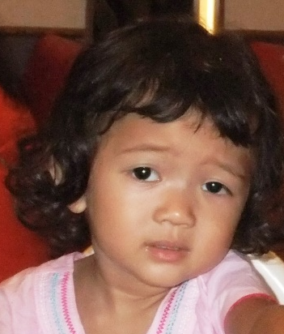 | 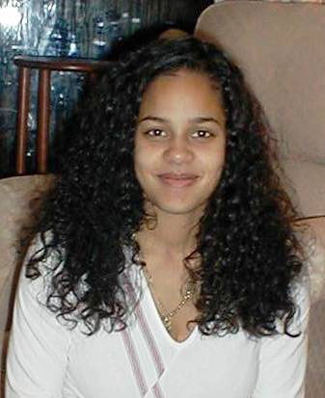 | 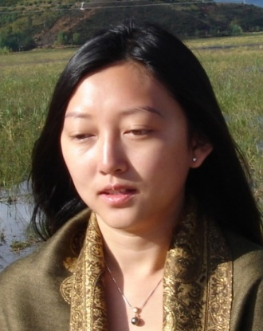 | 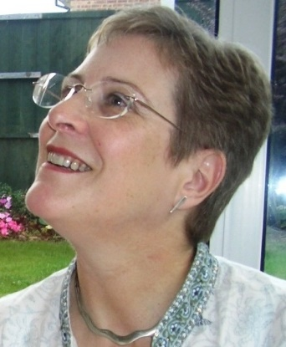
1 | 2 | 3 | 4
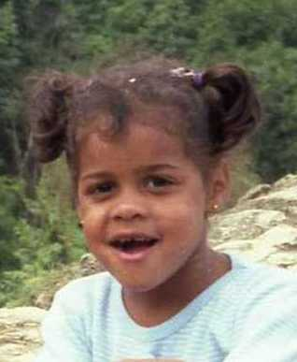 |  | 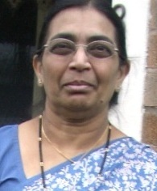 | 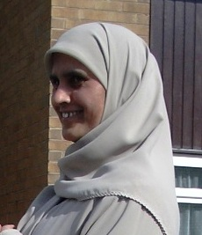
5 | 6 | 7 | 8
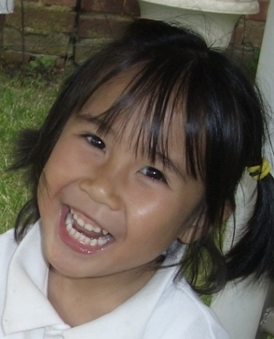 | 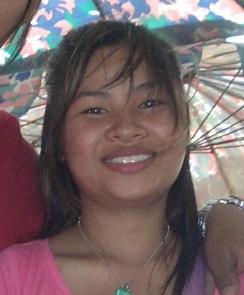 | 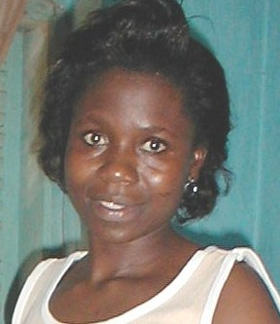 | 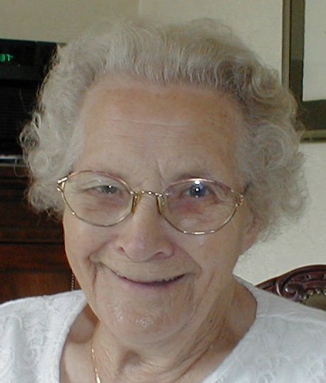
9 | 10 | 11 | 12
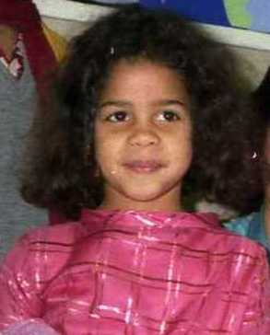 | 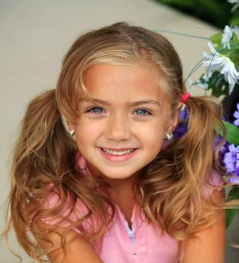 | 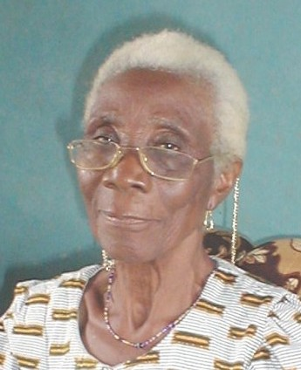 | 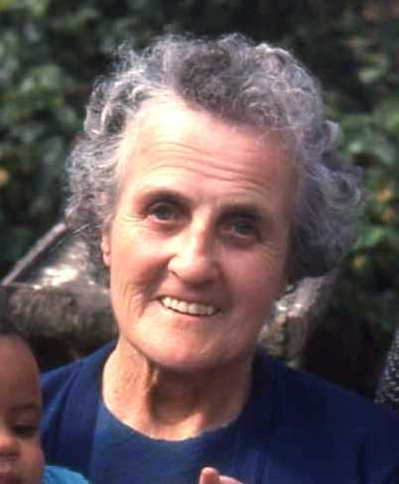
13 | 14 | 15 | 16
Think of a person. Your friends ask you questions to find out which one. You can only say Yes or No.

Racing to English  Activity 20a | Guess which person

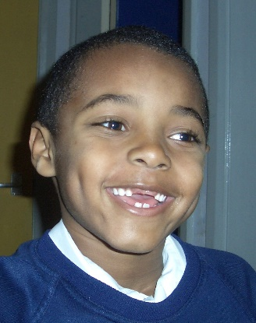 | 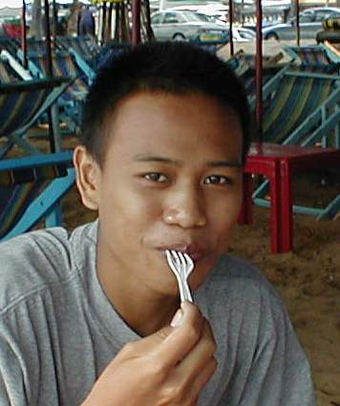 | 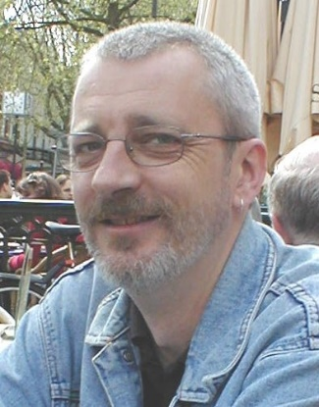 | 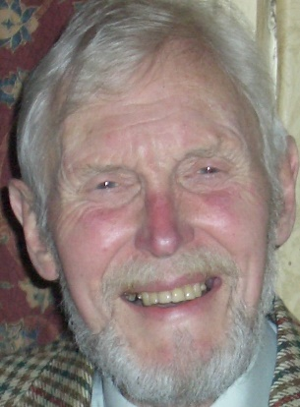
17 | 18 | 19 | 20
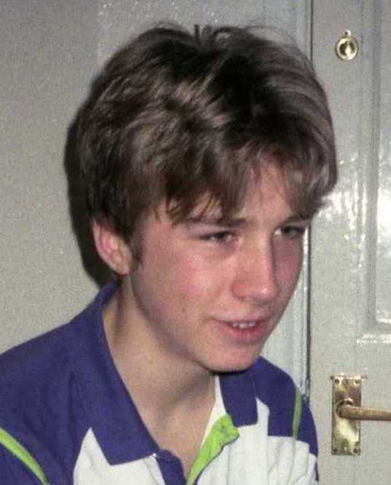 | 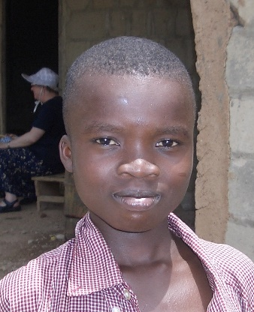 | 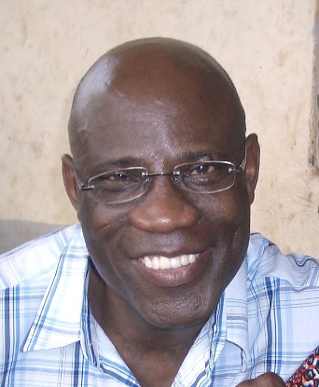 | 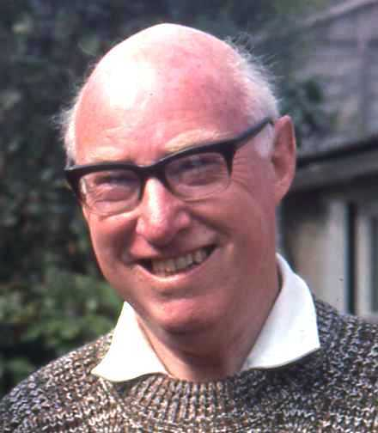
21 | 22 | 23 | 24
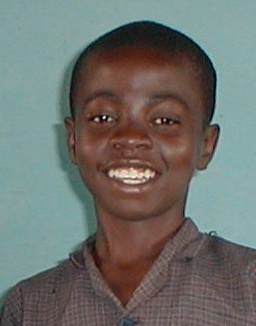 | 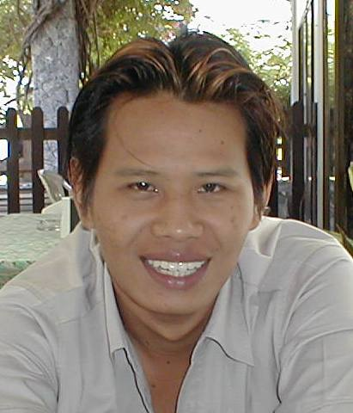 | 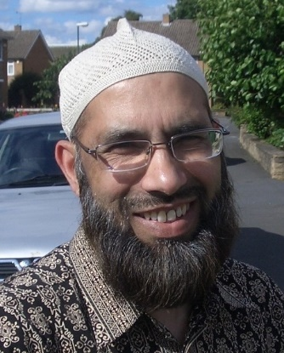 | 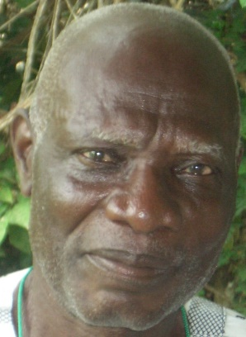
25 | 26 | 27 | 28
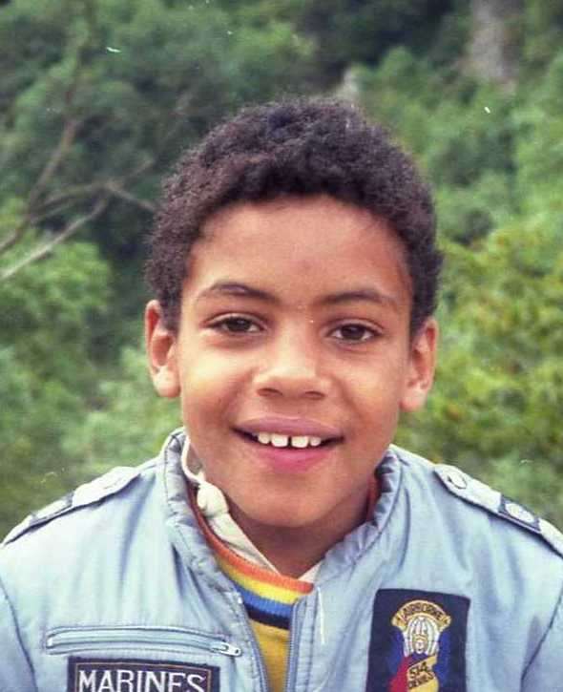 | 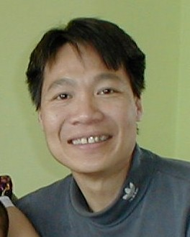 | 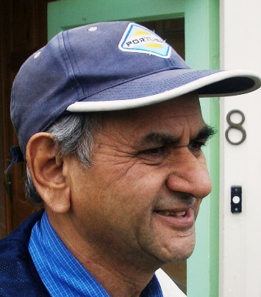 | 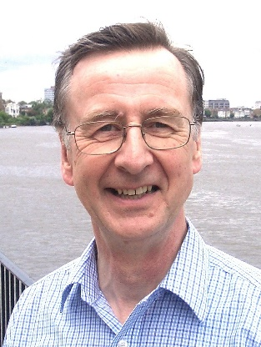
29 | 30 | 31 | 32
Think of a person. Your friends ask you questions to find out which one. You can only say Yes or No.

Racing to English  Activity 20a | Guess which person | Worksheet 1

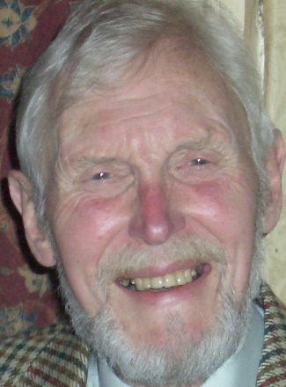
1 | 2 | 3 | 4

Ask your friend some questions:
Is | 1  2  3  4  5  6  7  8 | a  an | old man  old woman  young man  young woman  boy  girl | with | a cap?  a beard?  grey hair?  black hair?  long hair?  short hair?  a bald head?  glasses?  two teeth missing?
Now write 10 questions and answer them.

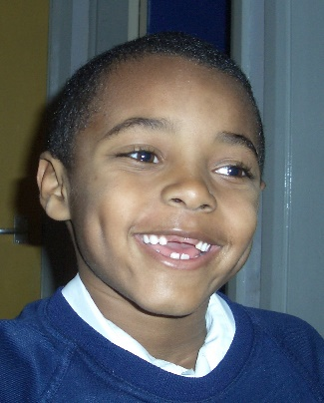 |  |  | 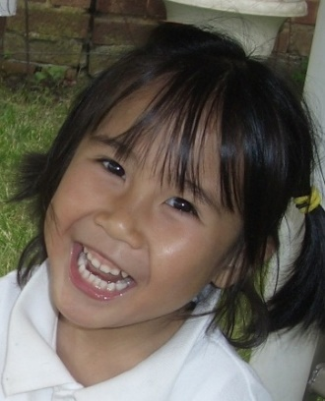
5 | 6 | 7 | 8

Racing to English  Activity 20a | Guess which person | Worksheet 2

Ask your friend some questions, then write 20 questions and answer them.
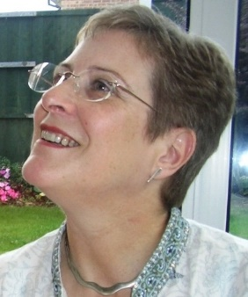1 | 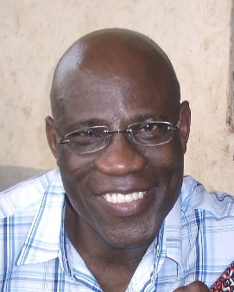2 | 3
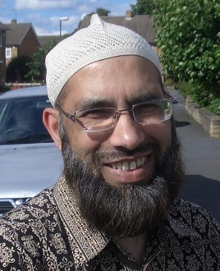4 | 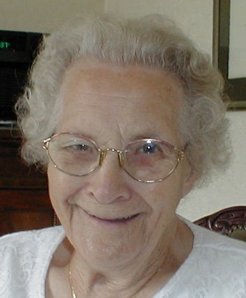5 | 6

Do | 1  2  3  4  5  6 | and | 7  8  9  10  11  12 | both have | glasses?  long hair?  grey hair?  black hair?  a beard?  a bald head?  a smile?

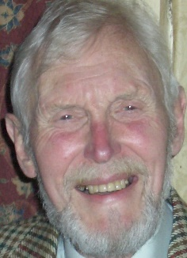7 | 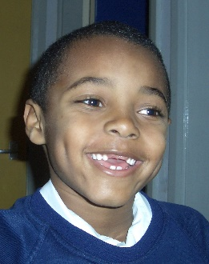8 | 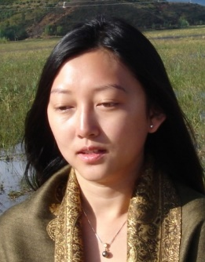9
10 | 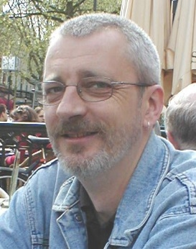11 | 12

Racing to English  Activity 20a | Guess which person | Worksheet  3

Work with a friend. Look at the pictures of people, then answer these questions.

- How many people are women? How many are men?
- How many people are children? How many are boys? How many are girls?
- How many people are young women? How many are young men?
- How many people are middle-aged women? How many are middle-aged men?
- How many people are old men? How many are old women?
- How many people are black? How many are white? How many are Asian?
- How many people have got black hair? How many have got grey hair?
How many have got no hair?
- How many men have got beards? How many women have got short hair?
- How many people are wearing glasses? How many are wearing a hat or scarf
on their head?

