Racing to English  Activity 15b | Occupations | TEACHERS’ NOTES

Language Learning Focus
Language function | Talking about regular activities and constant truths
Sentence structures | Simple present tense:  Do dentists drive tankers? A doctor treats sick people.

This photoset includes:
- A set of photo cards of people in various occupations and matching sentence cards
- A page of the Racing to English Picture Dictionary
- Worksheets for oral and written work

The photos and word cards can be used in many ways e.g.

ACTIVITY 1 – TURN AND ASK
Learners work in pairs and take it in turns to take a picture card and ask their partner “What’s this?” and at a higher level “What does a ------ do?.

ACTIVITY 2 – VISIBLE PAIRS (a game for two to four players)
1. Spread out the photo and sentence cards face down on the table
2. Take it in turns to turn over one (Yes ONE) card. Leave the card face up.
3. If any two cards match then the player who has just turned over a card must name the person’s occupation and read the sentence card and they can then take those two cards.
4. The player with the most cards at the end is the winner.

WORKSHEETS
Worksheets 1-3 look at the difference between ‘she carries’ and ‘they carry’ and between does and do. These worksheets are designed to be interactive and are based on question-based substitution tables e.g.:
Do | window cleaners  postmen  dentists  car mechanics  fire-fighters | clean  deliver  look after  put out  repair | cars?  fires?  letters?  teeth?  windows? |  | Yes they do.  No they don’t.

This substitution tables could generate 125 questions. Learners work in pairs to ask each other the questions orally before writing them. This oral work is an essential part of learning a language and completing a worksheet so will not be so effective if this oral work is omitted. I use substitution tables frequently both because they ensure a great deal of repetition and also because they show sentence patterns very clearly.
Worksheets 4 provides some more advanced work but still focuses on the simple present tense.

Racing to English  Activity 15b | Occupations | Picture  Dictionary

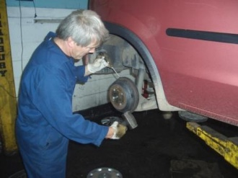  a car mechanic  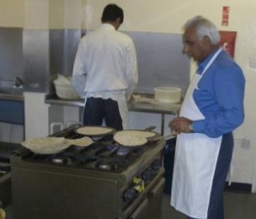  a chef  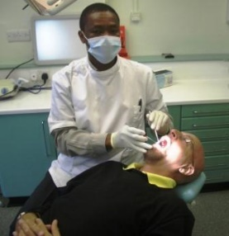  a dentist  a doctor  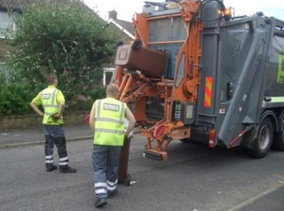  a dustbin man | 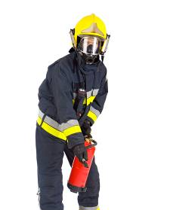  a fire-fighter  a nurse  a painter  a police officer  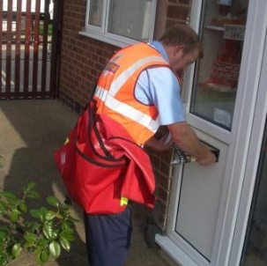  a postman | a shopkeeper  a surgeon  a teacher  a waiter  a window cleaner

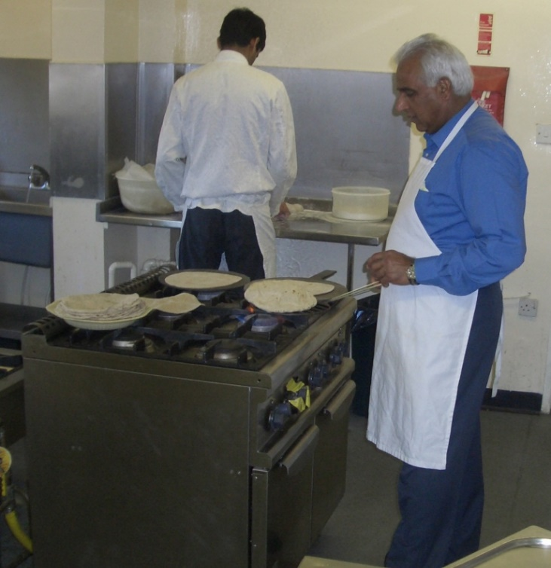 | A chef  cooks food in a restaurant.
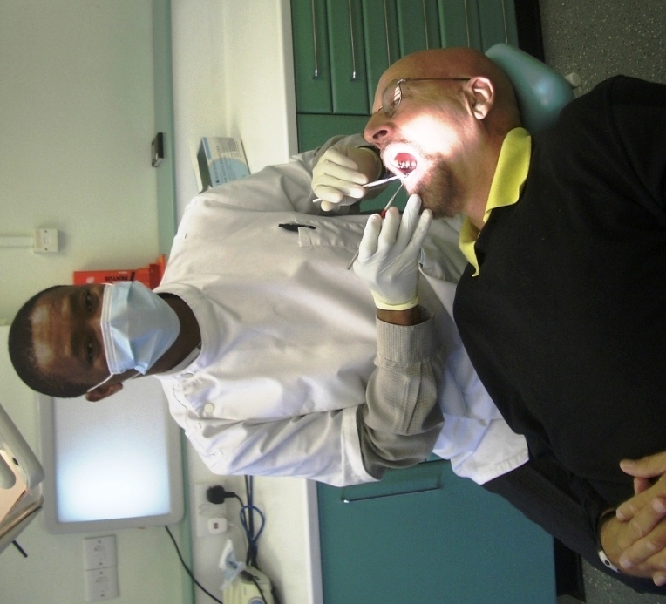 | A dentist  checks your teeth and treats them if you have toothache.
A doctor
treats sick people.
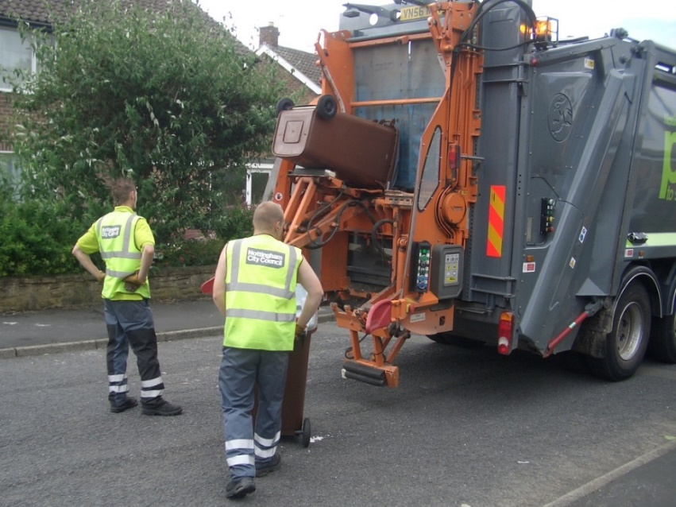 | A dustbin man  empties our bins and takes our rubbish away.
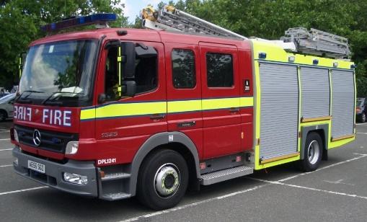  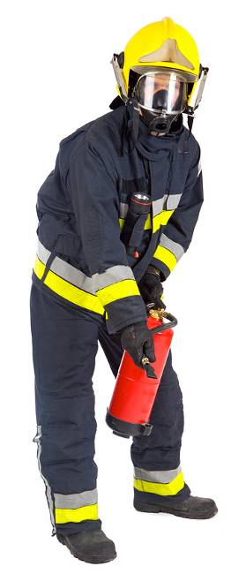 | A fire-fighter  puts out fires.
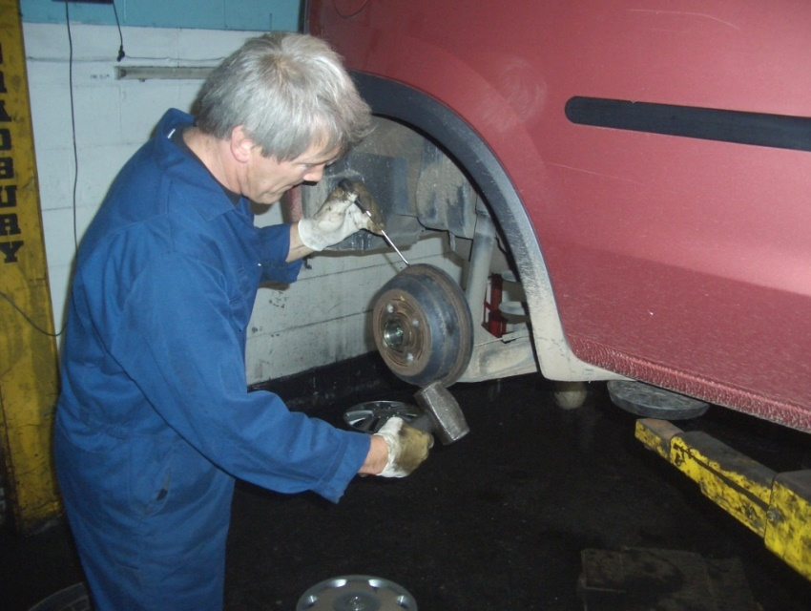 | A car mechanic  repairs cars.
A nurse
looks after sick people when they are in hospital.
A painter
paints your house.
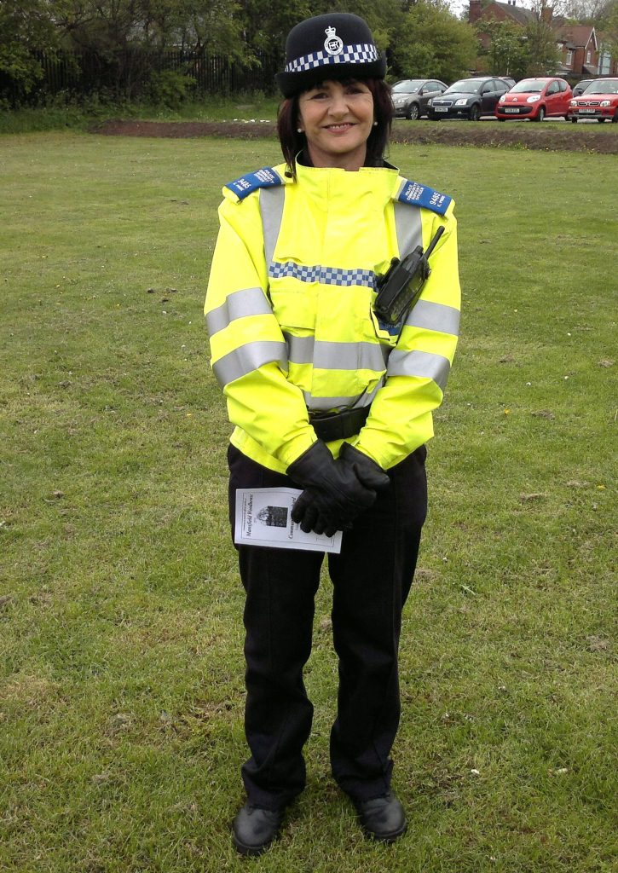 | A police officer  catches bad people.
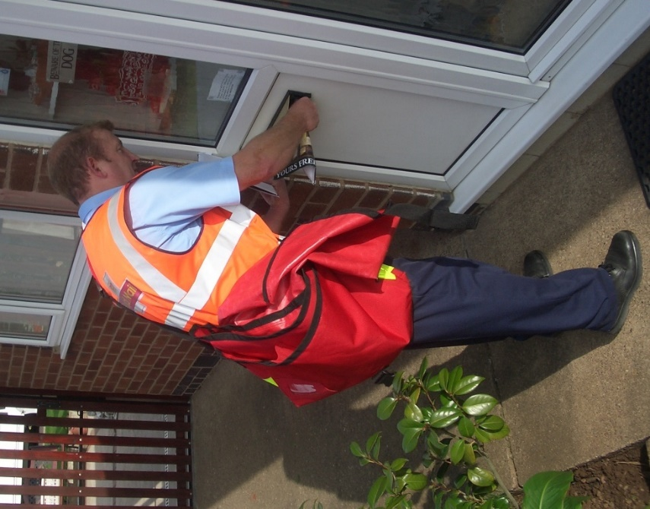 | A postman  delivers letters  to our houses.
A surgeon
operates on sick people.
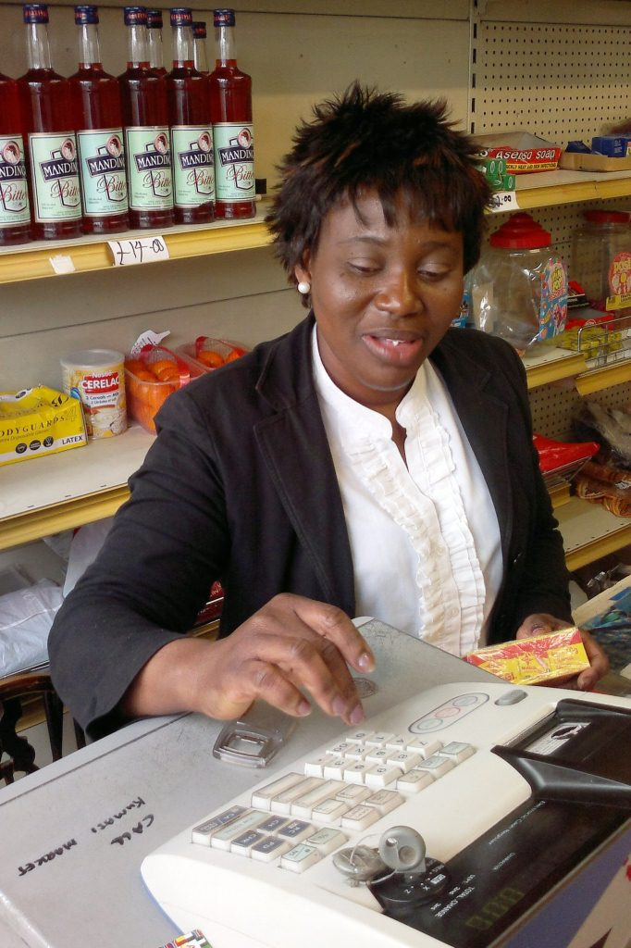 | A shopkeeper  sells things
A teacher
teaches children and helps them to learn
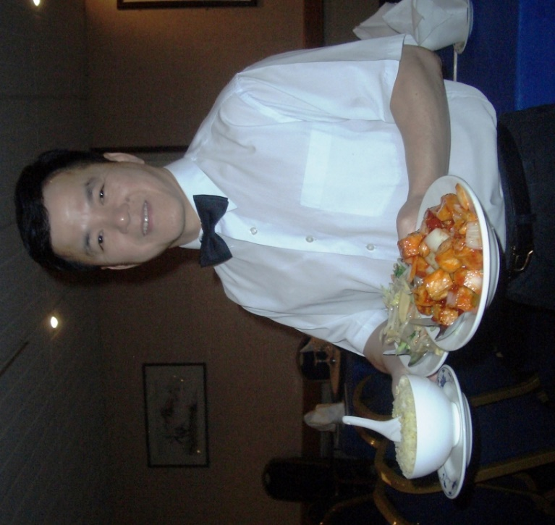 | A waiter  brings you food  in a restaurant.
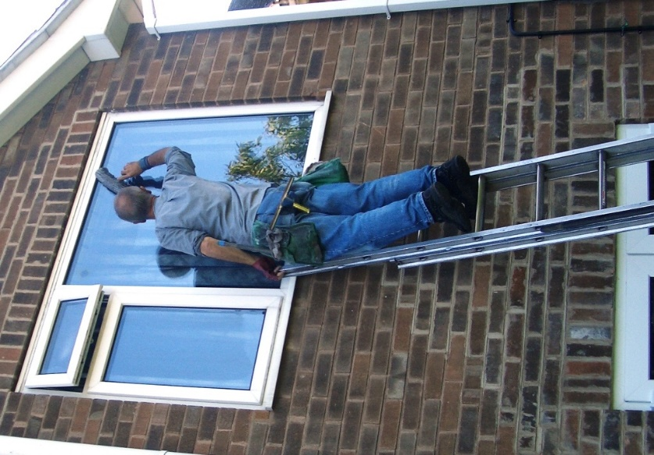 | A window cleaner  cleans windows.

Racing to English  Activity 15b | Occupations | Worksheet  1

Look at this
- A waiter carries food.
- Waiters carry food.

Read the correct sentences to your friend:
A chef  Chefs  A painter  Painters  A teacher  Teachers  A postman  Postmen  A waiter  Waiters | carries  carry  cook  cooks  deliver  delivers  paints  paint  teach  teaches | food.  houses.  letters.  children.
Now write the sentences

Ask your friend some questions:
Do | doctors  nurses  police officers  teachers | treat  look after  catch  teach | sick people?  bad people?  children? |  | Yes they do.  No they don’t.
Now write 10 questions and answer them.

Ask your friend some more questions:
Does | your doctor  your teacher  your father  your mother  your sister  your brother  your friend | cook  look after  catch  teach | bad people?  children?  food  sick people? |  | Yes he does.  Yes she does.  No she doesn’t.  No he doesn’t.
Now write 10 questions and answer them.

Racing to English  Activity 15b | Occupations | Worksheet  2

Ask your friend some questions:
Do | window cleaners  postmen  painters  dustbin men  dentists  car mechanics  tanker drivers  waiters  chefs  fire-fighters | carry  clean  cook  deliver  drive  empty  look after  paint  put out  repair | bins?  cars?  fires?  food?  houses?  letters?  sick people?  tankers?  teeth?  windows? |  | Yes they do.  No they don’t.
Now write 10 questions and answer them.

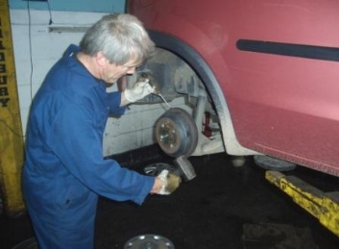

Ask your friend some of these questions:
- What does your mother do?
- What does your father do?
- What does your brother do?
- What does your sister do?
- What does your friend do?
- What does your auntie do?
- What does your uncle do?
- What does your cousin do?
Now write 4 questions and answer them.

Racing to English  Activity 15b | Occupations | Worksheet  3

Look at this
- A waiter carries food.
- Waiters carry food.

Read the correct sentences to your friend:
A car mechanic  Car mechanics  A dentist  Dentists  A doctor  Doctors  A dustbin man  Dustbin men  A fire-fighter  Fire fighters  A nurse  Nurses  A police officer  Police officers  A shopkeeper  Shopkeepers  A surgeon  Surgeons  A window cleaner  Window cleaners | catch  catches  cleans  clean  empties  empty  look after  looks after  operates on  operate on  put out  puts out  repairs  repair  sell  sells  treat  treats | bad people.  bins.  cars.  fires.  sick people.  teeth.  things.  windows. | 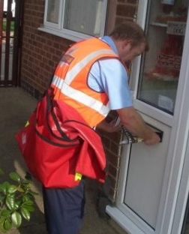
Now write the sentences

Racing to English  Activity 15b | Occupations | Worksheet  4

Jobs
Look at this list of jobs. Can you think of any other jobs? Ask your friends.
Write down 10 other jobs.
a car mechanic a chef a doctor a shopkeeper a waiter a postman
a window cleaner a police officer a dustbin man a dentist
a surgeon a nurse a teacher a painter a fire-fighter
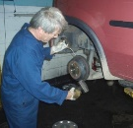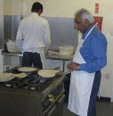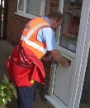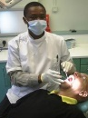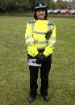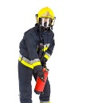

Similarities and differences

Look at these sentences:
- Nurses and postmen both wear uniforms.
- Nurses work inside, they work in hospitals, but postmen work outside, they deliver letters to our houses.
- Nurses work with people but postmen work with things.
Now choose three pairs of occupations and write some sentences comparing them like that.

Likes and dislikes
Look at this:
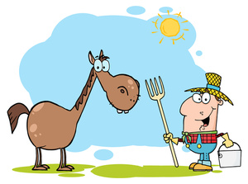  Would you like to be a farmer? |  | I would like to be a farmer because I like animals.
 |  | I wouldn’t like to be a farmer because they work outside and sometimes it is very cold and sometimes it rains.

Write a list of five jobs. Ask five friends about those jobs.
Ask them, ‘Would you like to be a _____? Why/why not?’

Now write about 10 jobs. Say if you would like to do that job or not. Say why.

