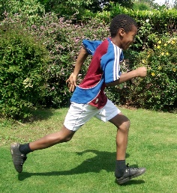 | Racing to English

Stage 2: Starting stories
CONTENTS

OVERVIEW
Step 9.  Narrating  intro to simple past tense.  I came, I saw, I wrote a story | Step 10  Narrating  Story file 1 (feelings) | Step 11  Narrating  Story file 2 (feelings)
Step 12  Narrating  Story file 3 (feelings) | Step 13  Do/Does 1  Talking about regular activities. “Do you wear a hat on your head?” | Step 14  Animals – Do/Does 2  Constant truths  e.g. "Lions eat meat
Step 15  Do/Does 3  Constant truths “Birds build nests in spring” | Step 16  Narrating  Story file 4 (feelings) | Step 17  Narrating  Miscellaneous stories
Step 18  Position & direction | Step 19  Position  Describe & draw | Step 20  Guess which  Description
Maths 3  Shapes and fractions | Pronunciation activities

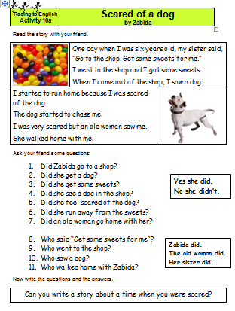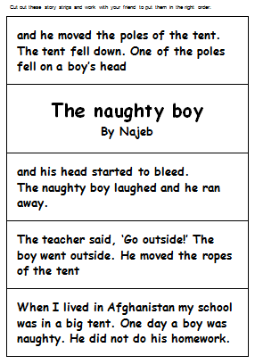 | 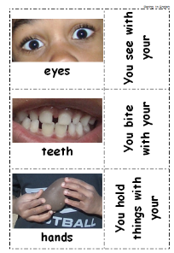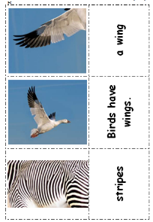 | 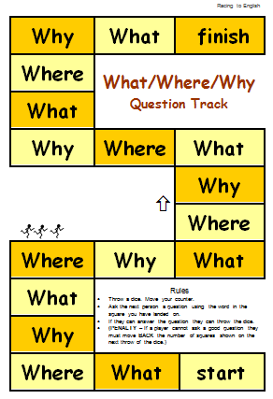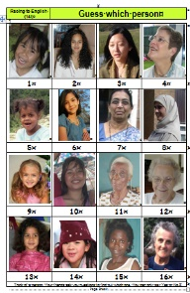
stories | photosets | games

Step  9a | Narrating for younger learners  intro to simple past tense - I came I saw, I wrote a story | Step  9a

Language Learning Focus
Language function | reporting incidents and narrating stories about the past
Sentence structures | simple past tense  - I went, I looked, I pointed  - I didn't go, I didn't look, I didn't point  - Did you go? Did you look? Yes I did/No I didn't.  Past continuous tense  - Where were you?  - What were you doing? I was reading a book.
Vocabulary | Emphasis is on verbs: went, worked, bought, took, collected, cleaned, cooked, etc.

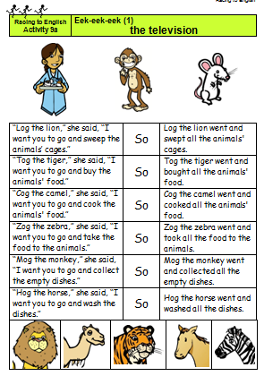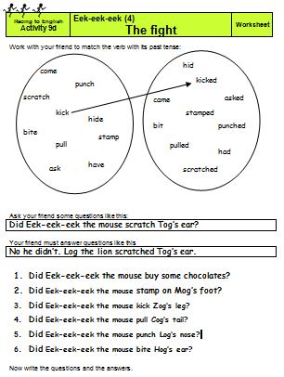  9a 5 part story about Eek-eek-eek the mouse |  | 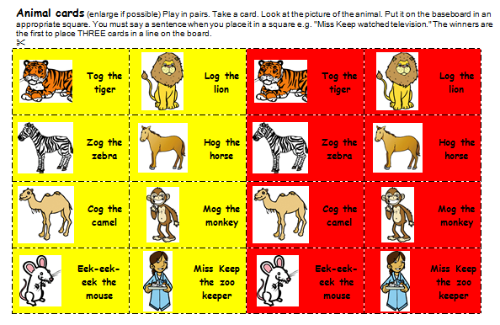  9a2 Eek-eek-eek 1  Line of 3 game
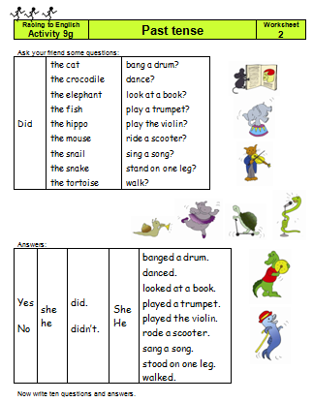  9h.  4 past tense worksheets for a wide age range | 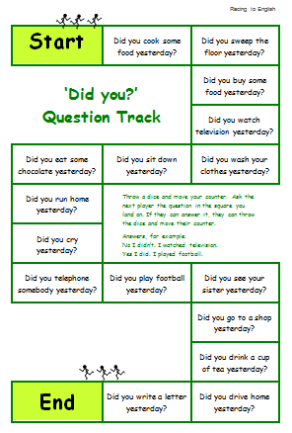 9i. “Did you” question track

Step  9b | Narrating for older learners intro to simple past tense - I came I saw, I wrote a story | Step  9b

Language Learning Focus
Language function | reporting incidents and narrating stories about the past
Sentence structures | simple past tense  - I went, I looked, I pointed  - I didn't go, I didn't look, I didn't point  - Did you go? Did you look? Yes I did/No I didn't.  Past continuous tense  - Where were you?  - What were you doing? I was reading a book.
Vocabulary | Emphasis is on verbs: went, worked, bought, took, collected, cleaned, cooked, etc.

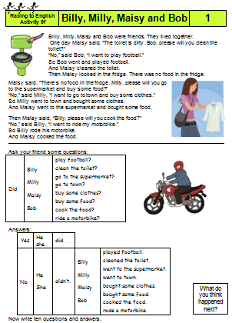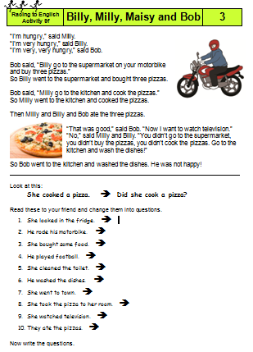  9f. A three part story  about Billy, Milly, Maisy & Bob |  | 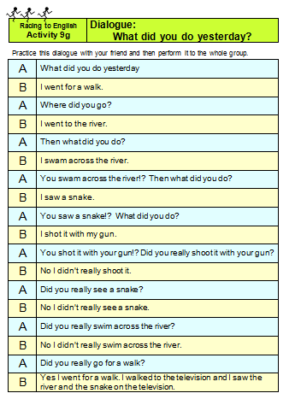  9g. Dialogue:  What did you do yesterday?
9h. Four past tense worksheets | 9i. “Did you”  question track | 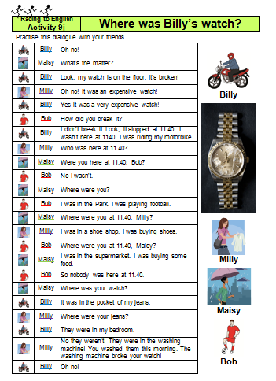  9j. Dialogue: “Where was Billy’s watch?”

Step  10 | Narrating  Story file 1 (feelings) | Step  10

Language learning focus
Language function | Narrating
Sentence structures | Simple past tense:  I looked for my watch/I ran into the road/He told my mother.  Why did he throw a brick?
Vocabulary | Each of the stories relates to an emotion:  scared, worried, sad, angry, hurt, frightened, cross

This step includes some stories written by young people.  Each story illustrates an emotion and has  - a story sheet with the story and some questions  - a sequencing activity | The stories are  10a. Scared of a dog  10b. Sad I lost watch  10c. Angry fell in road  10d. Worried baby & penny  10e. Angry about snake  10f. Hurt by broken glass  10i. Naughty boy  The step also includes  10h. Past tense gap filling  10x. the What/Why/Where track  This can be used with any story.

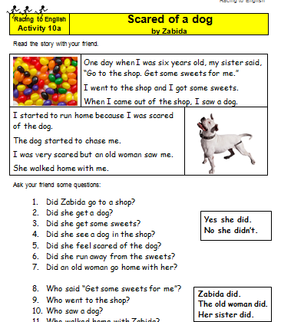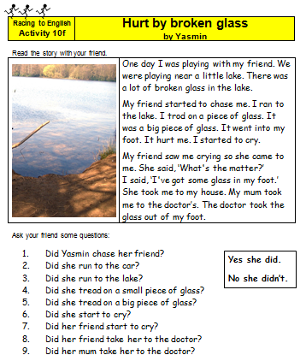
Some examples of the stories
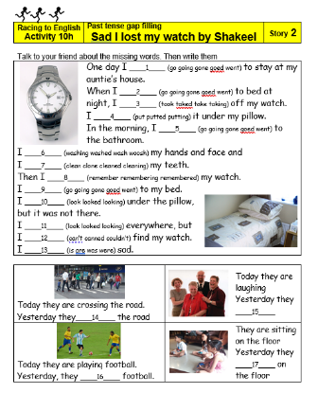  10h Past tense gap filling | 10x. What/Why/ Where track

Steps  11/12 | Narrating  Story file 2(feelings) | Steps  11/12

Language learning focus
Language function | Narrating
Sentence structures | Simple past tense:  I looked for my watch/I ran into the road/He told my mother.
Vocabulary | Each of the stories relates to an emotion:  jealous, sorry ,guilty, curious, upset, terrified, embarrassed, etc.

These steps include some slightly longer stories, again each written by a young person. Most of the stories illustrates an emotion and except for the first few they all have a story sheet with the story, two worksheets and a sequencing activity
11a. Cross brother  11b. Frightened at a river  11c. Fighting  11d. Sorry about hot water  11e. Four snakes  11f. Guilty about my lost rings  11g. Jealous of a key  11h. Silly fishing  11i. locked in a house | 12a. Terrified of a crocodile  12b. Curious about a noise  12c. No English  12d. Upset by a motor scooter accident  12e. Embarrassed  12f. Bees in the tree  12g. Tired: the bike and the donkey  12h. From Africa to England

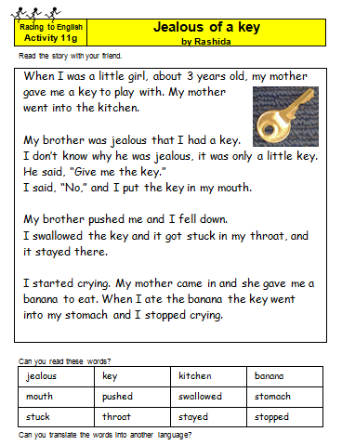 | 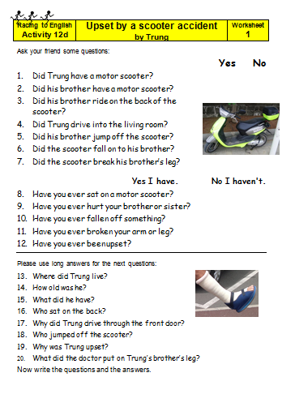 | 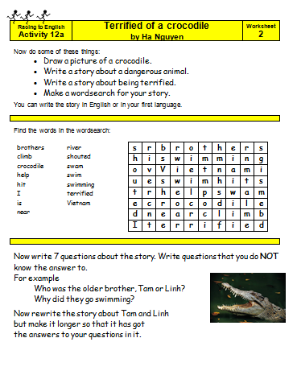 | 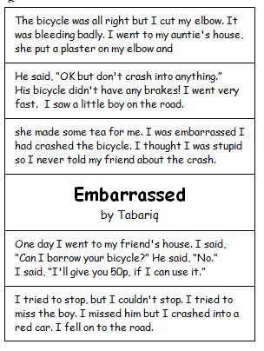
Some examples of the stories, showing the story page,
the two worksheets and the sequencing activity
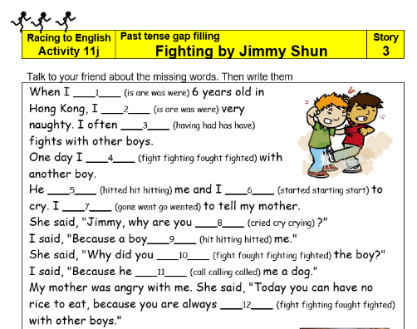 |  | 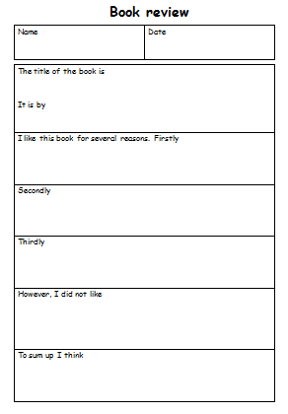 | 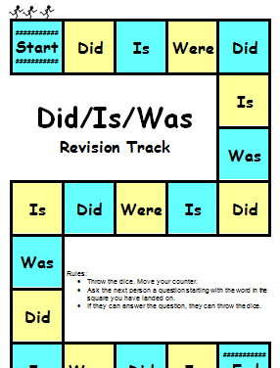
11j/12j Past tense gap filling |  | 11x. Writing frames | 12y. Did/Is/Was revision track

Step  13a | Do/Does (1) for younger learners | Step  13a

Language Learning Focus
Function | Talking about regular activities
Sentence structures | Simple present tense  I write. We write. He/She/It writes. Do you write? Does he/she/it write?  This stall sells watches.
Vocabulary | Key vocabulary items include:  - before, after  - a number of common verbs e.g. see, bite, hold, wash, clean, paint  - more clothes e.g. sandals, scarves, sunglasses, wallets

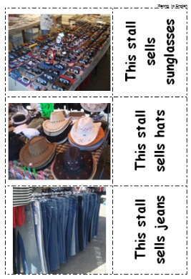  13a. Clothes market | 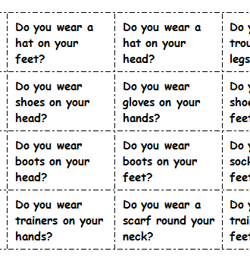  13b. Clothes 4 in a line | 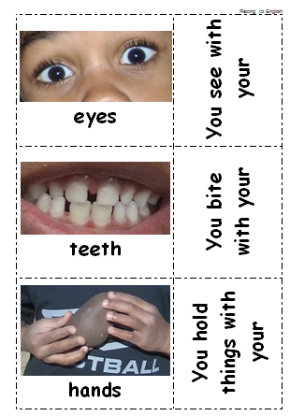  13c. Do you photoset | 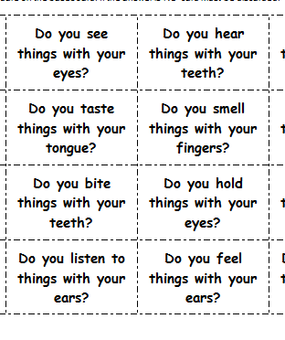  13d. Senses “Do you...?” 4 in a line
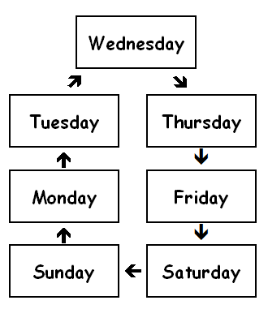  1ee. Days of the week. | 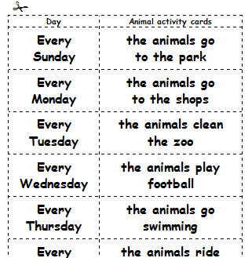  13f. Days at the Zoo | 13g, 13h, 13i, 13j, 13k  Cog the camel.  a 5 part story for younger learners | 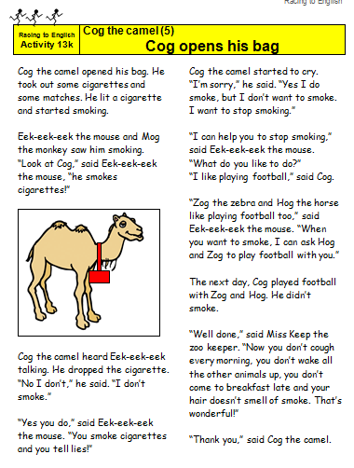
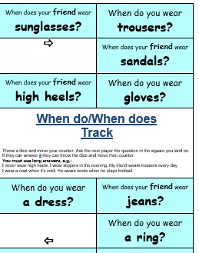  13m. “When do/ When does” track | 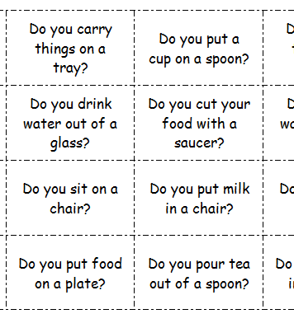  12n Do you – dining room 4 in a line

Step  13b | Do/Does (1) for older learners | Step  13b

Language Learning Focus
Language function | Talking about regular activities
Sentence structures | Simple present tense  I write. We write. He/She/It writes. Do you write? Does he/she/it write?  This stall sells watches.
Vocabulary | Key vocabulary items include:  - before, after  - a number of common verbs e.g. see, bite, hold, wash, clean, paint  - more clothes e.g. sandals, scarves, sunglasses, wallets

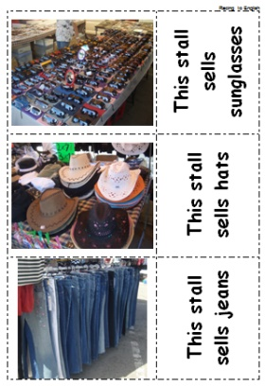  13a. Clothes market | 13b. Clothes 4 in a line | 13c. Do you photoset | 13d. Senses “Do you...?” 4 in a line
13e. Days of the week. | 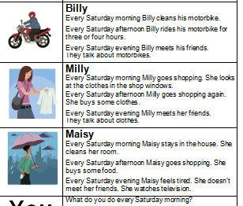  13L. “Saturdays with Milly, Billy, Maisy and Bob”  (for older learners) | 13m. “When do/ When does” track | 12n Do you – dining room 4 in a line

Step  14 | Animals – Do/Does 2  Constant truths "Lions eat meat” | Step  14

Language Learning Focus
Language functions | Naming animals and their parts  Identifying ability/possession/experience  Describing features/Giving reasons
Sentence structures | - Can a whale fly? Has it got a long neck?  - Do zebras have long necks? Do mammals lay eggs?  - Fish have gills so that they can breathe under water.
Vocabulary | - Names of farm, pet and wild animals  - Parts & features of animals,  - Animal classes, i.e. birds, reptiles, mammals, etc.

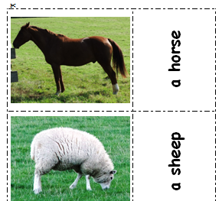  14a. Farm & pet animals | 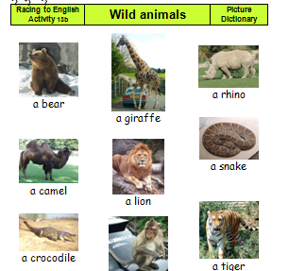  14b. Wild animals | 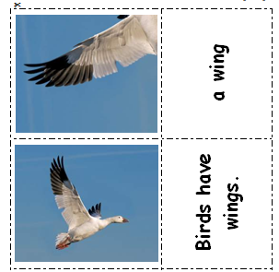  14c. Animal parts | 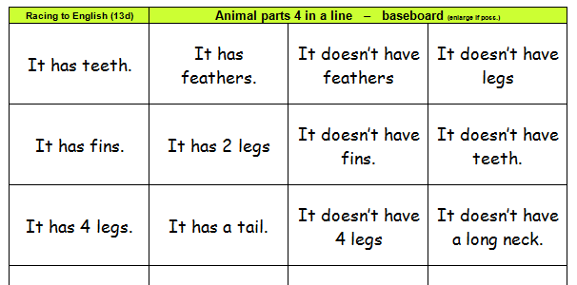  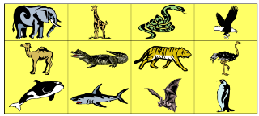  14d. Animal parts
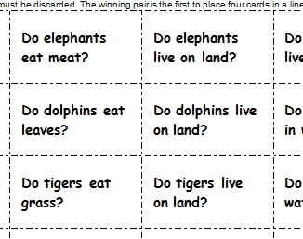  14e. Animal lives  4 in a line | 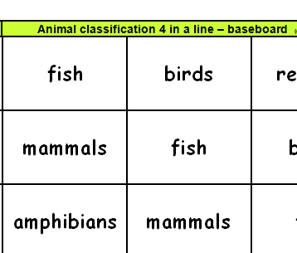  14f. Animal classes 4 in a line | 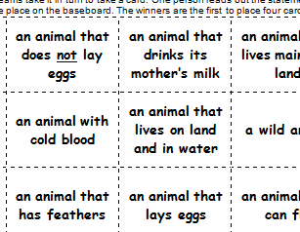  14g. Animal sets 4 in line | 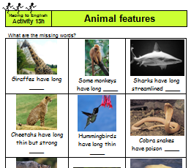  14h. Animal features
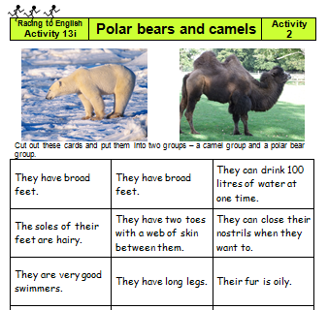  14i Polar bears and camels | 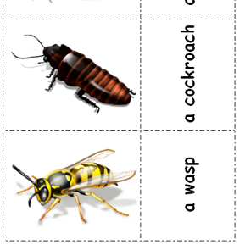  14j. Insects etc.

Step  15 | Do/Does 3  Constant truths – “Birds build their nests in the spring.” | Step  15

Language Learning Focus
Language function | Talking about regular activities and constant truths
Sentence structures | Simple present tense:  Do dentists drive tankers? Birds lay eggs in the spring. You knock in nails with a hammer. When a liquid freezes it turns into a solid.
Vocabulary | Houses/Occupations/Seasons/Tools/Matter

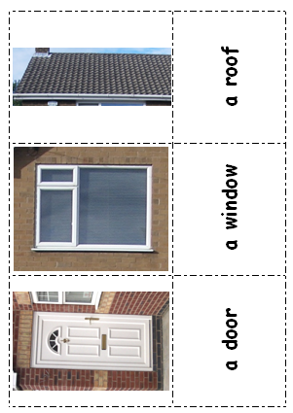  15a. Houses photoset | 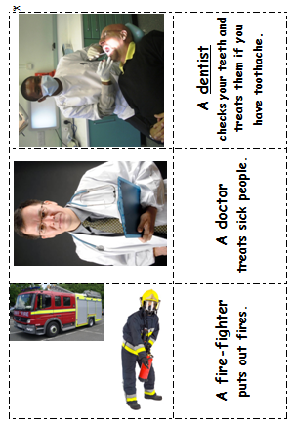  15b. Occupations photoset | 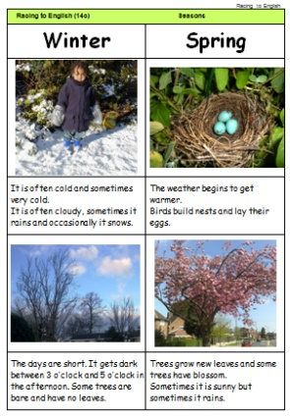  15c. Seasons photoset | 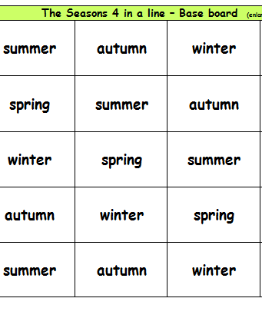  15d. Seasons  4 in a line
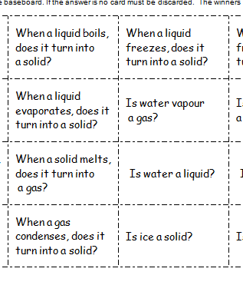  15e. Matter:  4 in a line | 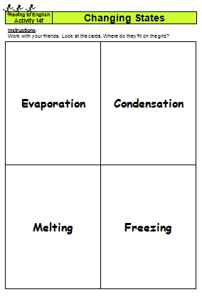  15f. Changing states | 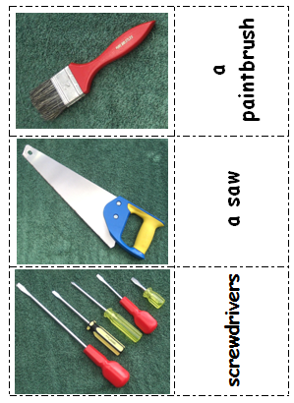  15g. Tools photoset | 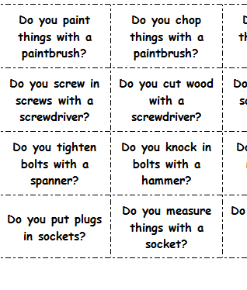  15h. Tools  4 in a line
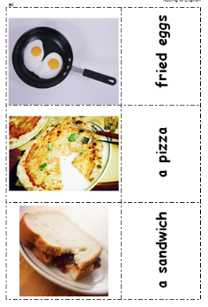  15i. Food photoset | 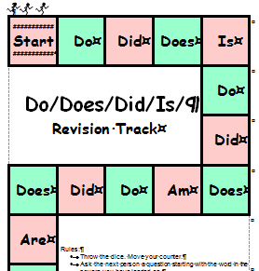  15x. Do/Does/Did/Is revision track

Step  16 | Narrating  Story file 4 (feelings) | Step  16

Language learning focus
Language function | Narrating
Sentence structures | Simple past tense:  I looked for my watch/I ran into the road/He told my mother.
Vocabulary | Each of the stories relates to an emotion or feeling:  sad, painful, disappointed, scared, upset, etc.

This step includes some more stories that are slightly more difficult than those in step 12, again each written by a young person.  Most of the stories illustrate an emotion and they all have  - a story sheet with the story  - two worksheets  - a sequencing activity | The stories are  16a. Scared of a camel  16b. Painful scorpion  16c. Disappointed football match  16d. Drowning in a river  16e. Upset by a thief  16f. Tickling spider  16g. Sad for a blind man

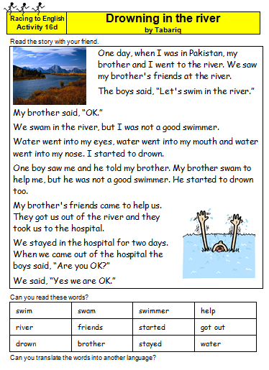 | 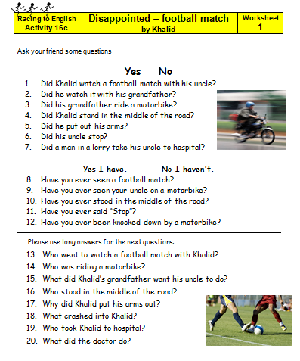 |  | 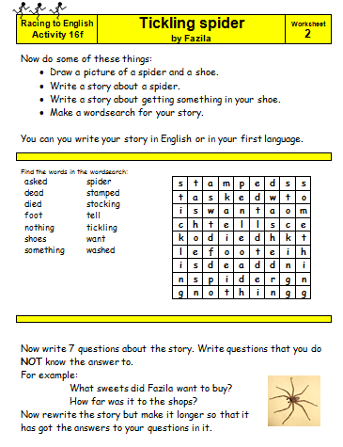 |  | 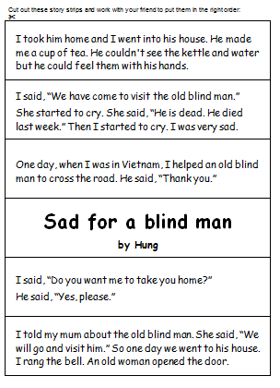
Some examples of the stories, showing the story page,
the two worksheets and the sequencing activity
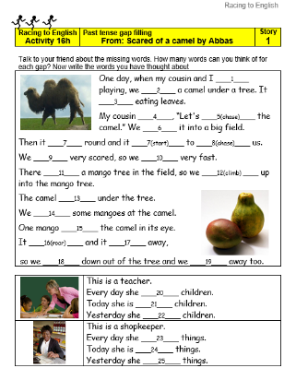 |  | 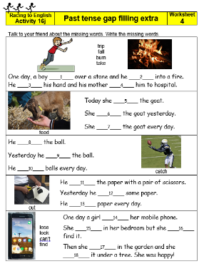
16h/16j Past tense gap filling

Step  17 | Miscellaneous stories | Step  17

Language learning focus
Language function | Narrating
Sentence structures | Simple past tense:  I looked for my watch/I ran into the road/He told my mother.
Vocabulary | Each of the stories relates to an emotion or feeling:  sad, painful, disappointed, scared, upset, etc.

This step includes a variety of stories some written by young people others reflecting traditional stories.  Each story includes;  - a story sheet with the story  - two worksheets  - a sequencing activity |  | The stories are  17a. The learner driver  17b. Frightened by a frog  17c. Kindness (a traditional story from Ghana)
This step also includes  - 17x. The Book Review Question Track  - 17y. Blank tracks | 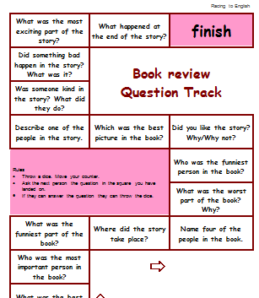  17x Book Review Question Track |  | 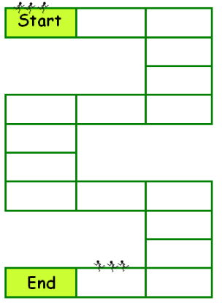  17y. Blank tracks

Step  18 | Position & direction | Step  18

Language Learning Focus
Language functions | Describing position and directions
Sentence structures | - They are running towards the house.  - Take the first turning on the right.
Vocabulary | Prepositions of place: in, on, under, between, behind, in front of, on the left, in the middle  Prepositions of motion: towards, away from, straight ahead

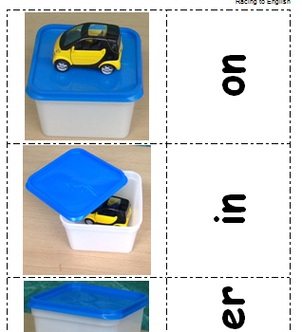  Copy of 7c.  Prepositions 1 | 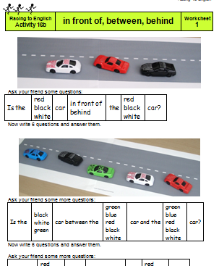  18b. Between, etc. | 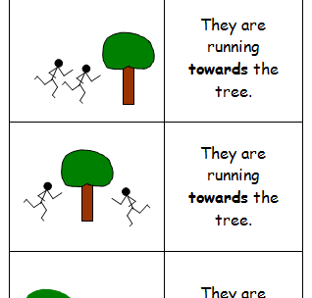  18c. Preposition  picture pairs
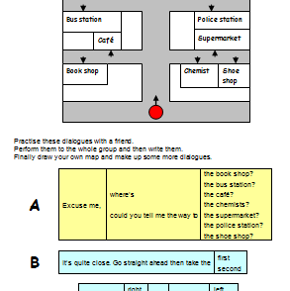  18d. Dialogue – directions | 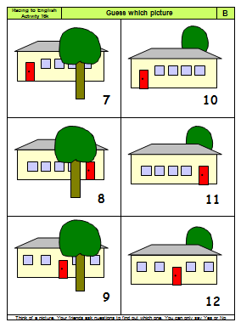  18e. Guess which picture | 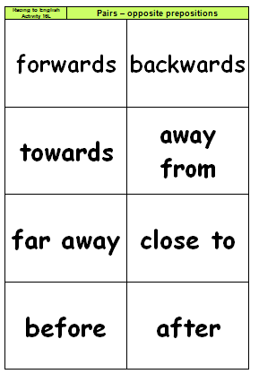  18f. Opposite preposition pairs

Step  19 | Position: Describe and draw | Step  19

Language Learning Focus
Language functions | Describing position and directions
Sentence structures | - Is there a tree to the left of the house?  - Draw a triangle on the right-hand side.
Vocabulary | Prepositions of place: in, on, under, between, behind, in front of, on the left, in the middle  Prepositions of motion: towards, away from, straight ahead

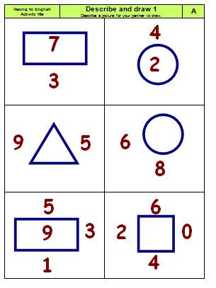  19a. Describe and draw (1) | 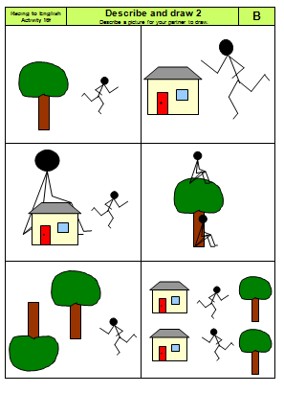  19b. Describe and draw (2) | 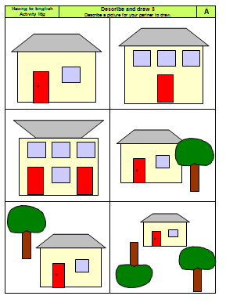  19c. Describe and draw (3)
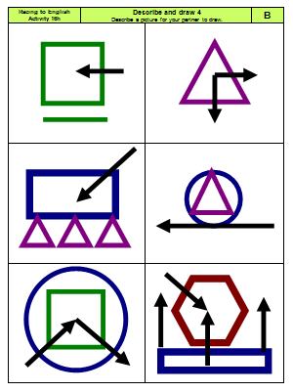  19d. Describe and draw (4) | 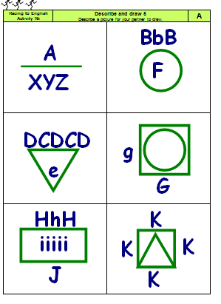  19e. Describe and draw (5) | 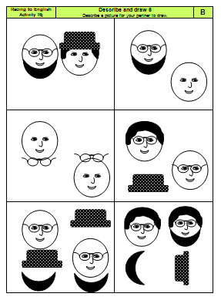  19f. Describe and draw (6)

Step  20 | Guess which (description) | Step  20

Language Learning Focus
Language functions | Describing people and animals
Sentence structures | - Has she got grey hair?  - Is it sitting down?  - Is it red with black spots?  - Etc.

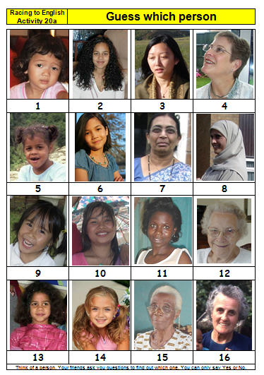  20a. Guess which  person | 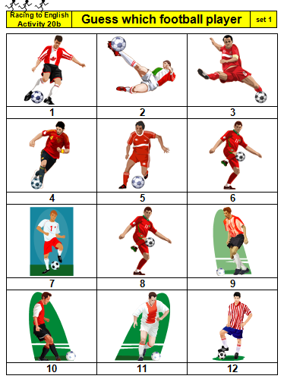  20b. Guess which  football player | 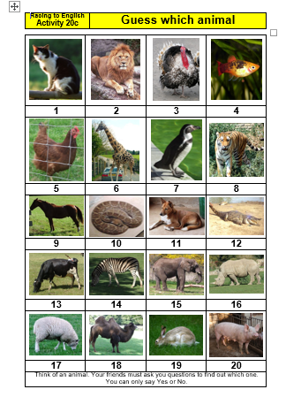  20c. Guess which  animal
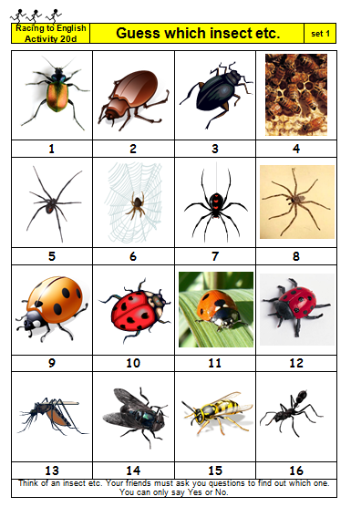  20d. Guess which  insect | 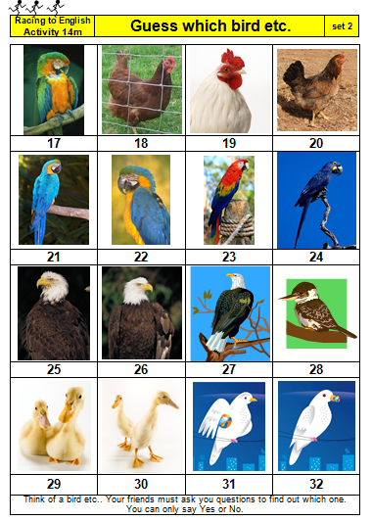  20e. Guess which  bird

Step  M3 | Maths 3  Shapes | Step  M3

Language learning focus:
Language functions | Naming shapes
Sentence structures | - It's a hexagon.  - It has a semi-circular head and a hexagonal body.
Vocabulary | NOUNS:  a hexagon  a parallelogram  an octagon  a trapezium  a semi-circle  etc.  sides  angles  symmetry | ADJECTIVES:  circular  semi-circular  rectangular  triangular  hexagonal  etc.  curved  straight  parallel | parts of circles  - radius  - diameter  - circumference  angles  obtuse/acute/right

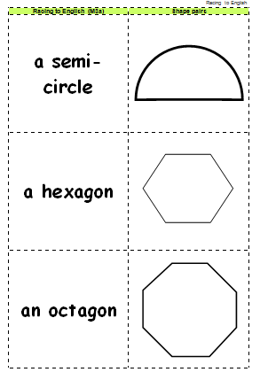  M3a. Shape pairs | 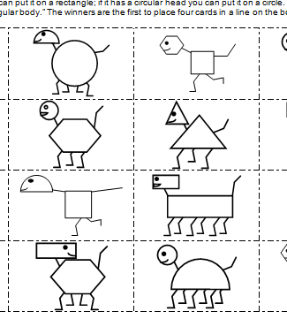  M3b.  Shape monsters  4 in a line | 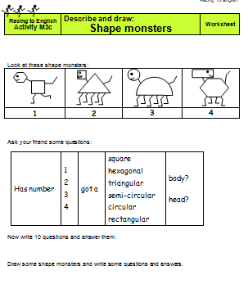  M3c. Describe & draw shapes | 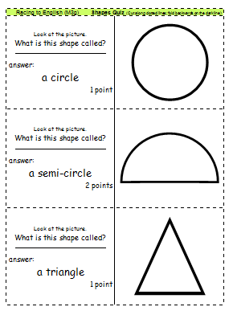  M3d. Shapes quiz
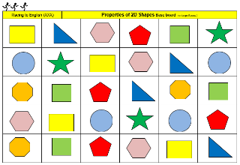  M3e. Properties  of 2D Shapes | 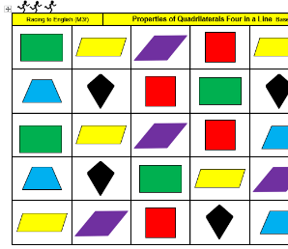  M3f Properties of quadrilaterals

Step  M4 | Maths 4  Fractions and factors | Step  M4

Language learning focus:
Language functions | Talking about fractions
Sentence structures | - What’s a third of…  - What is a quarter plus/minus a third?
Vocabulary | quarter, half, sixteenth, etc.

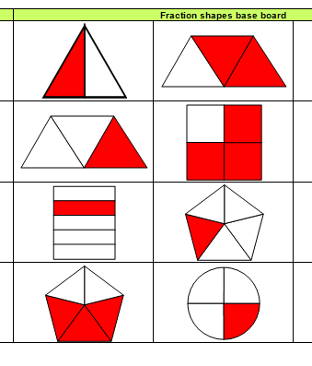  M4a.  Fraction shapes  4 in a line | 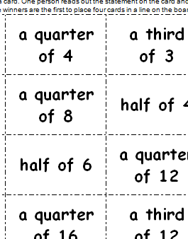  M4b. Fractions numbers  4 in a line | 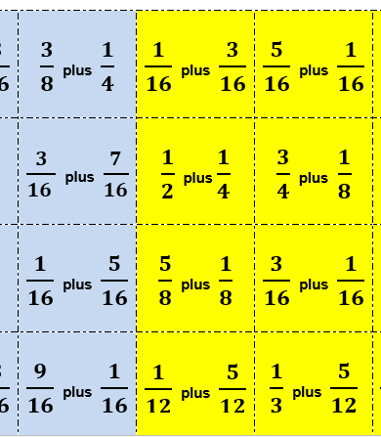  M4c.  Adding fractions  4 in a line | 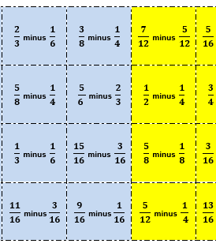  M4d. Subtracting fractions  4 in a line
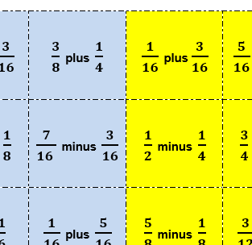  M4e  Adding/subtracting fractions  4 in a line | 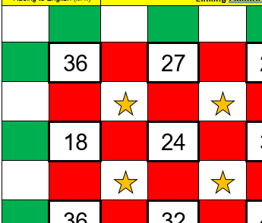  M4f  Linking factors

Step  Pr | Pronunciation activities | Step  Pr

CONTENTS
Activities that focus on pronunciation, they also support the development of spelling. The activities are designed to help learners to hear the difference between sounds and to pronounce them clearly. Most of the activities are based on pairs of sounds that many learners find problematic.
Only use these activities if the learners are having particular pronunciation problems.

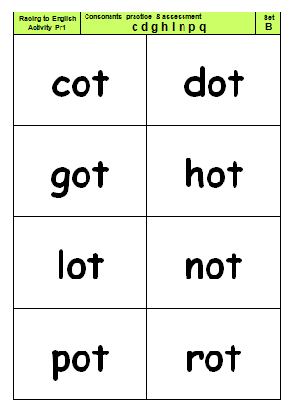  Pr1 & Pr2  Consonants | 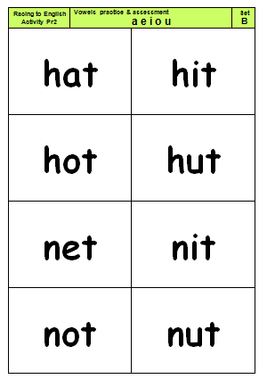  Pr3, Pr4 & Pr5  Short vowels | 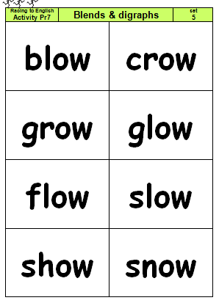  Pr6 & Pr7  blends & digraphs | 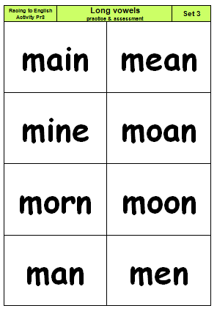  Pr8 & Pr9  Long vowels
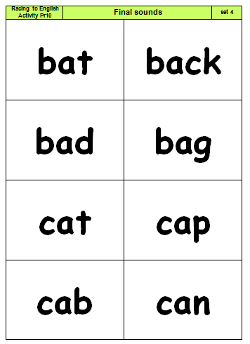  Pr. 10  Final sounds | 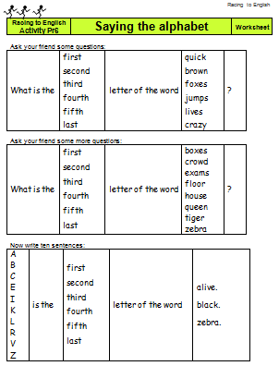  Pr11.  Saying the alphabet | 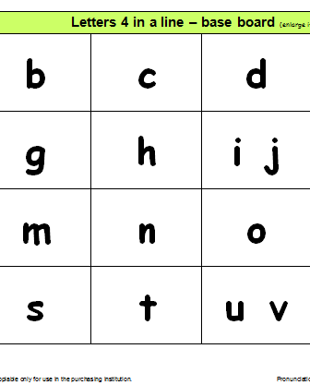  Pr12.  Letters  4 in a line | 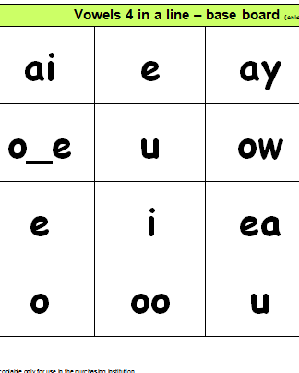  Pr13.  Vowels  4 in a line

