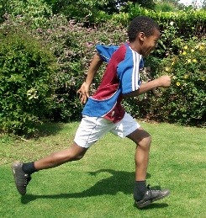 | Racing to English

Stage 3: Talking & reading
CONTENTS

Step 21  Have/has intro  talking about the past as it relates to the present  “Have you lost your …?” | Step 22  Have/has 2  I’ve already paid for my ticket (so I have it now) | Step 23  Future  with "going to"  I'm going to paint the wall.
Step 24  Comparing  Are you taller than your brother? | Step 25  Describing:  Spot the difference | Step 26  Describing  It's made of wood.  It's near the box.
Step 27  Writing and Narrating  Story prompts, etc. | Step 28  True stories (1)  Narrating using past tense | Step 29  True Stories (2) Passive: It was built. Rabbits are eaten ... It has been ...
Step 30  True stories (3)  Could, would, when, vocab | Step 31  True stories (4)  Had done | Step 32  True stories (5)  Copernicus, seasons, etc.
Step 33  True stories (6)  Animals Fossils & Darwin | Step 34  True stories (7)  Species & More Fossils | Step 35  True stories (8)  Geology
Step 36  True Stories (9)  Deep time | Step 37  True Stories (6)  If | Step 38  Maps: Guess which country
Step 39  Grammar tracks | Step 40  Miscellaneous | Math(s) 4  Speaking maths worksheets

Have/has intro | Step | 21

Language learning focus
Language function | Talking about the past as it relates to the present
Sentence structures | Present perfect tense:  - Have you washed…?  - Have you remembered? No I’ve forgotten.  - I haven’t seen…  - Where has he gone? Has anyone seen him?
Vocabulary | Vocabulary arising from the stories

For younger learners
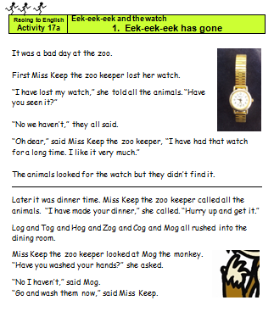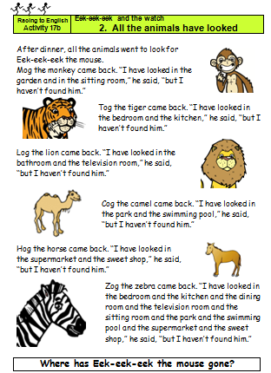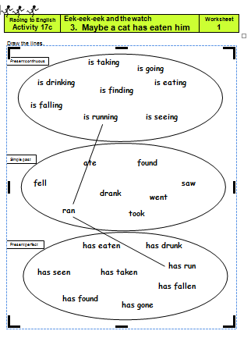  21a, 21b, 21c Eek-eek-eek & the watch - a story in 3 parts | 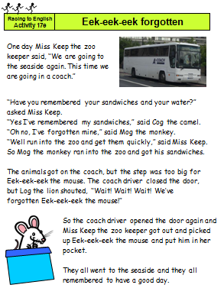  21d Eek-eek-eek forgotten
For older learners
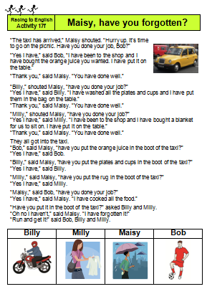  21e. “Maisy,  have you forgotten?” | 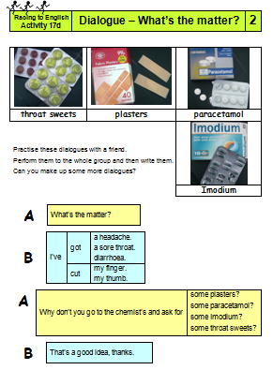  21f. Dialogue: “What’s the matter?” | 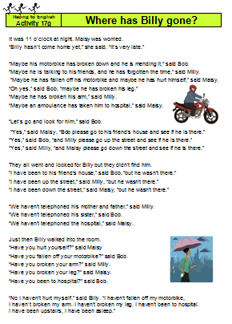  21g. “Where has Billy gone?” | 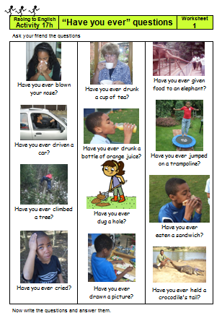  21h. “Have you ever” questions

Have/has (2)  Do/Does revision | Step | 22

Language learning focus
Language functions | Talking about the past as it relates to the present.  Talking about regular activities.
Sentence structures | Present perfect tense: Have you ever swum in the sea?  Simple present: What does an engine do?
Vocabulary | Holidays: sea, beach, hotel, etc.  Funfair: big/Ferris wheel, coconuts, candy, etc.  Vehicle parts: engine, windscreen, wheel, bonnet, etc.  Train travel: railway lines, passengers, platform, train, etc.

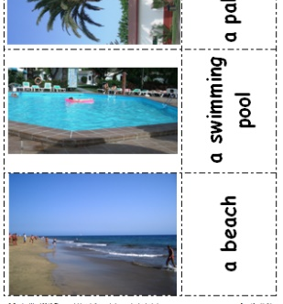  22a. Holidays | 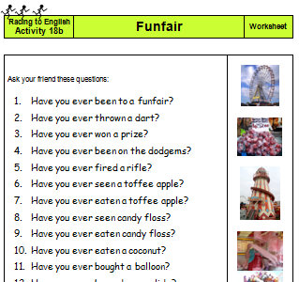  22b. Funfair | 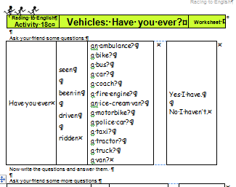  22c. Vehicles:  “Have you ever?” | 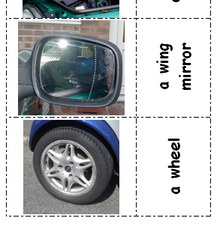  22d. Vehicle parts
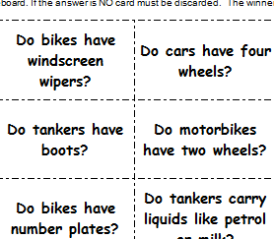  22e. Vehicles  4 in a line | 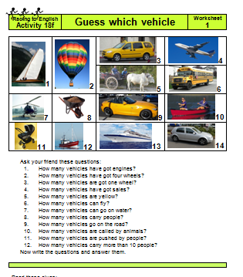  22f. Guess which vehicle | 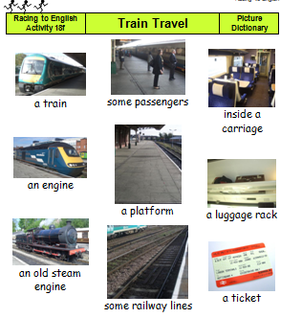  22g. Train travel | 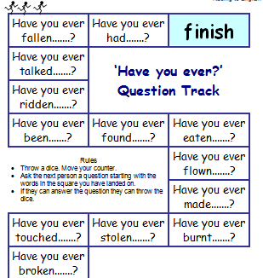  22h. Have you ever track
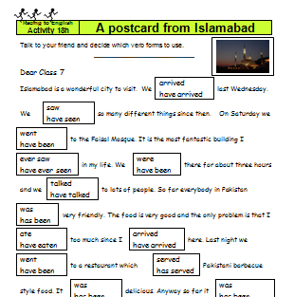  22j. Postcard from Islamabad | 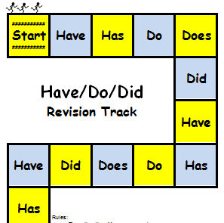  22j. Have/Do/Did revision track

Future with “going to” | Step | 23

Language learning focus
Language functions | Talking about the future  Asking politely
Sentence structures | Future using ‘going to’  - He is going to run away.  - Are you going to swim in the sea?  - I think this means it's going to be sunny tomorrow.  Asking politely  - Would you like to come to my house?
Vocabulary | Weather: sunny, cloudy, rainy, a rainbow, a puddle, etc.

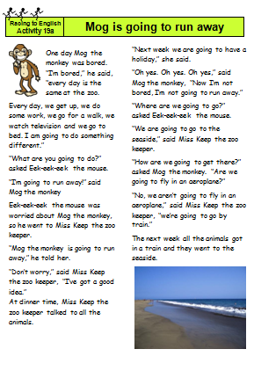  23a. Mog is going to run away.  For young learners | 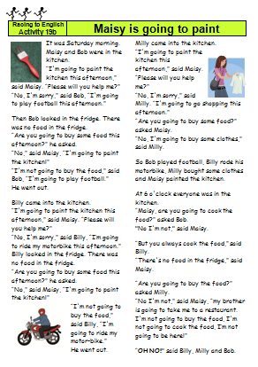  23b.  Maisy is going to...  For older learners | 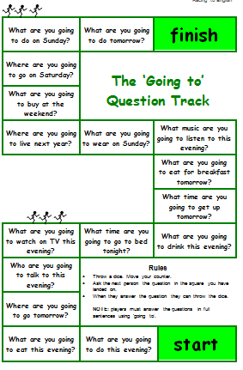  23c. The “going to” question track. | 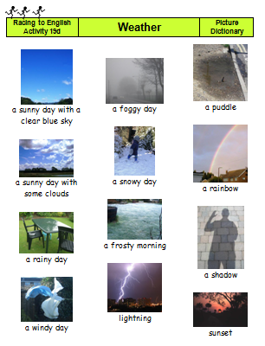  23d. Weather photoset
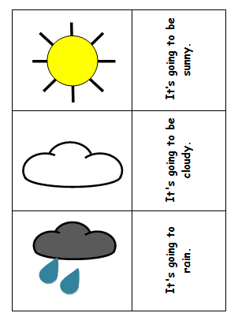  23e. Weather symbols | 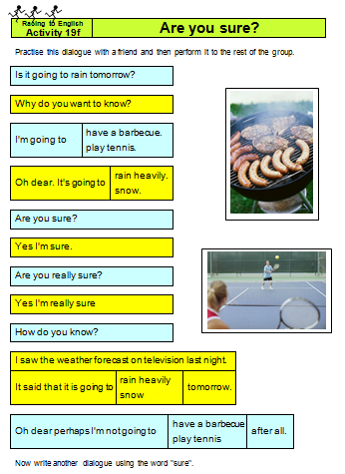  23f. Dialogue  "Are you sure?" | 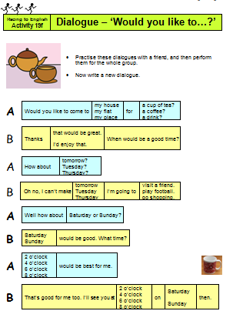  23g. Dialogue – “Would you like to...?”

Comparing | Step | 24

Language learning focus
Language function | Comparing things
Sentence structures | - Are you taller than Asif? Pam is older than Tim.  - Is the blue car more expensive than the red car?  - Does the red car cost more than the blue car?  - What is the difference in price?  - Amit thought that book A was funnier than book B  - This coat is too big.  - Is Jupiter the biggest planet?

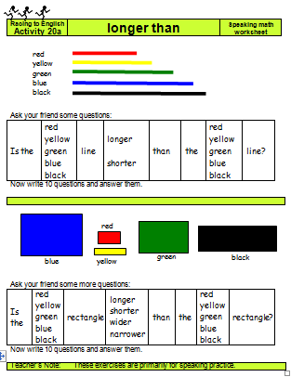  24a. Longer than oral worksheet | 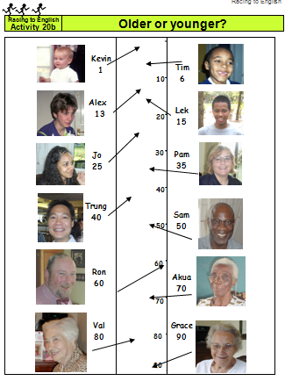  24b. Older or younger | 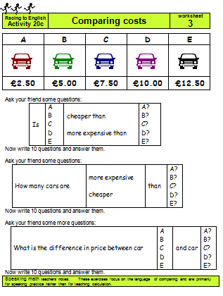  24c. Comparing costs | 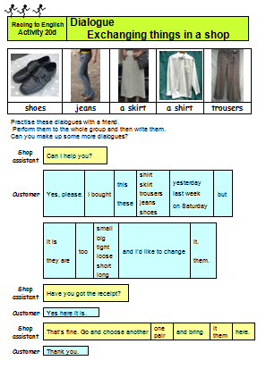  24d. Dialogue exchanging things
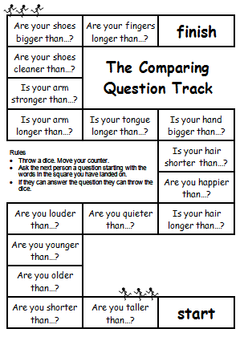  24e. The comparing track | 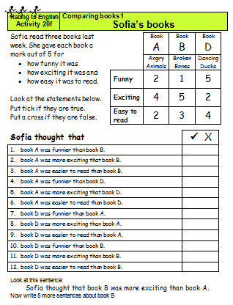  24f. Comparing books | 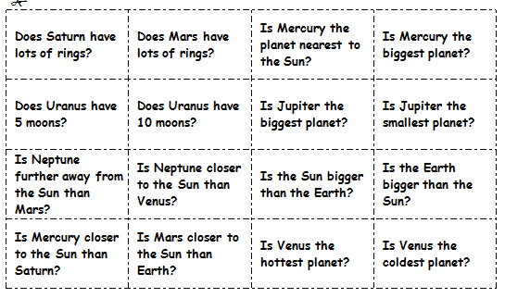  24g. Solar system – 4 in a line

Describing: Spot the difference | Step | 25

Language learning focus
Language function | Describing – objects and position
Sentence structures | - Is the lid on the saucepan?  - Is he wearing a blue shirt?
Vocabulary | Position: on, in, to the left of, upside down, etc.  Adjectives, e.g. open, closed, cloudy, green, high, open, sunny

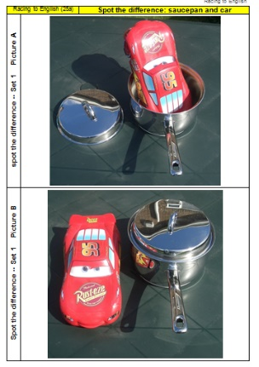 | 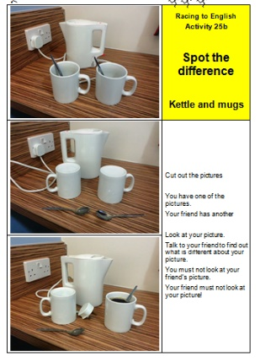 | 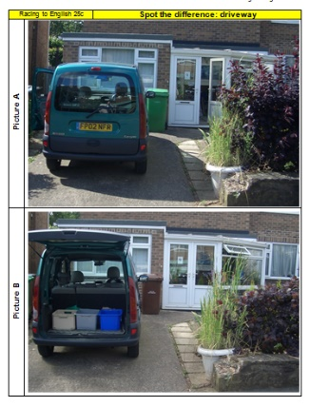
25a. Spot the difference  Saucepan | 25b. Spot the difference  Kettle and mugs | 25c. Spot the difference  Driveway
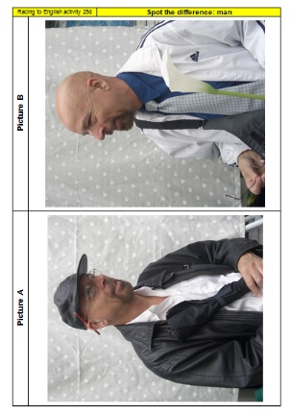 | 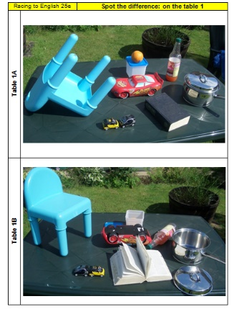 | 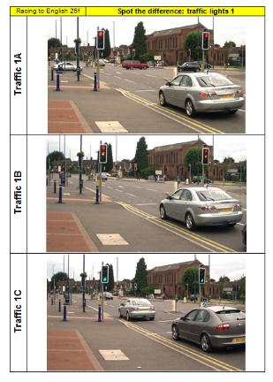
25d. Spot the difference  Man | 25e. Spot the difference  On the table | 25f. Spot the difference  Traffic lights

Describing 2 | Step | 26

Language learning focus
Language function | Describing – objects, materials and position
Sentence structures | - It's made of metal.  - Rough is the opposite of smooth.  - The music was so loud that my ears began to hurt.
Vocabulary | Materials: metal, wood, glass, plastic, cardboard, leather  Adjectives, e.g. open, closed, cloudy, green, high, open, sunny  A range of opposite adjectives, e.g. asleep/awake, clean/dirty, wet/dry

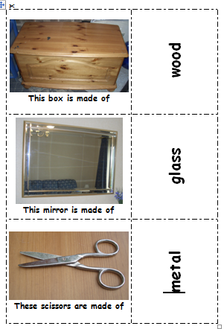 | 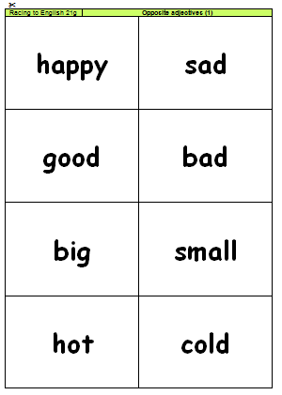 |  | 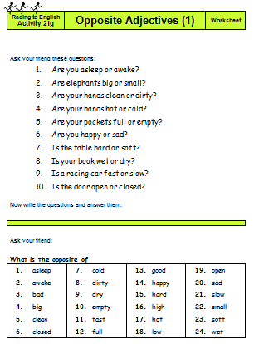
26a. Materials photoset | 26b, 26c, 26d Three opposite adjective activities, each with a worksheet
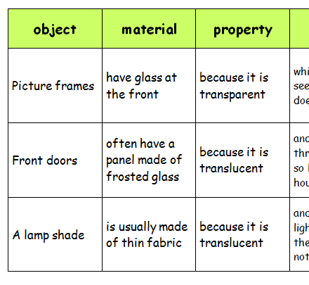
26e. Transparent, translucent opaque

Writing and Narrating  Story prompts, etc. | Step | 27

Language learning focus
The activities in this step are designed
- to stimulate learners’ writing and
- to extend their vocabulary

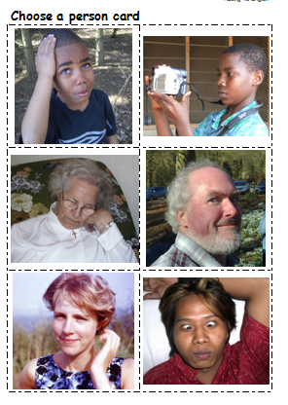 |  | 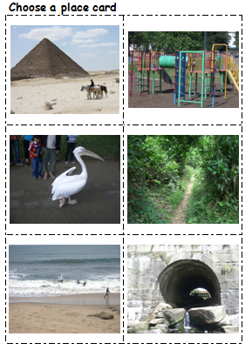 | 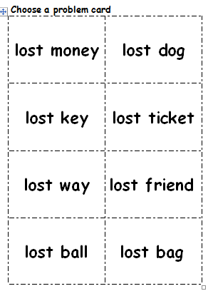
27a, 27b, 27c, 27d, 27e.  Story prompts | Each of these story prompts includes  - a set of people cards,  - a set of place cards and  - a set of problem cards.  Learners work together to choose one of each type of card and then use them to develop a story.
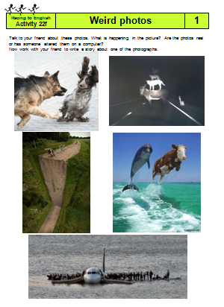  27f. Story prompts:  weird photos |  | 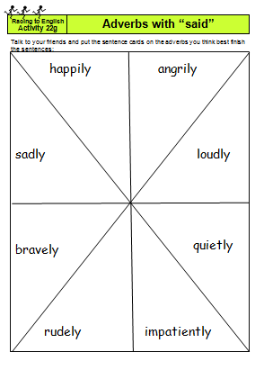  27g. Adverbs with said (vocab development) | 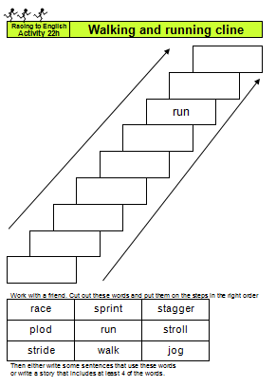  27h. Clines  (vocab development)

True stories (1)  Narrative using simple past tense | Step | 28

Language learning focus
Language function | Narrating
Sentence structure | Simple past tense  - He invented, sold, etc.  - Rosa refused to give up her seat.

This step includes:
- some one-page stories about famous people. Each story is accompanied by questions and a blank filling worksheet.
- Information gap activities
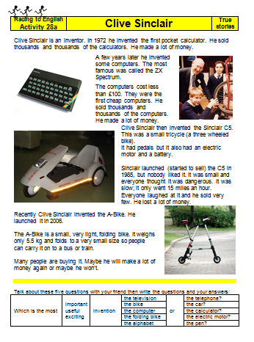  28a. Clive Sinclair | 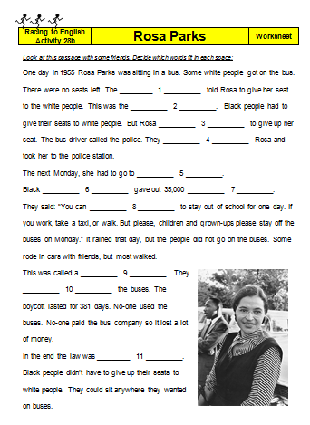  28b. Rosa Parks | 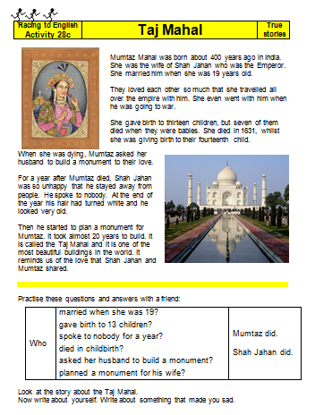  28c. Taj Mahal | 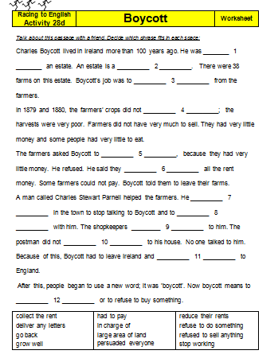  28d. Boycott
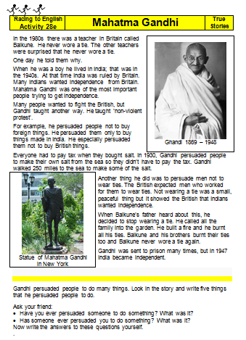  28e.  Mahatma Gandhi | 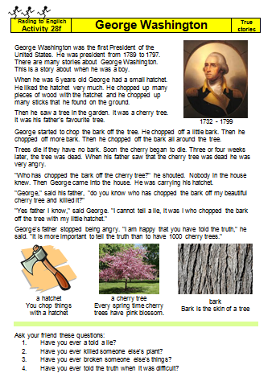  28f.  George Washington | 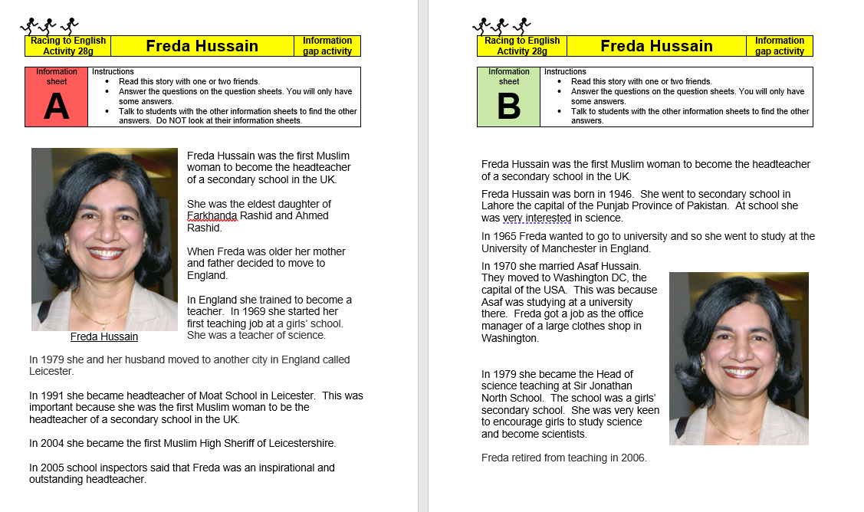  28g Freda Hussain  Info gap activity

True stories (2): the passive | Step | 29

Language Learning Focus: the passive
Language functions |  | Sentence structures
Narrating |  | - Tower Bridge was built in 1894.
Constant truths |  | - Rabbits are eaten by foxes.
The past as it relates to present |  | - The house has been sold.
Making suggestions |  | - Maybe he broke his leg.
Key vocabulary  London | burnt down  designed |  |  | destroyed  erected | started finished | first opened  reopened
Key vocabulary  Tutankhamen | maybe  buried |  |  | discovered  hidden | broken  covered | tomb  pharaoh
Key vocabulary  ‘has been’ | boarded up  cut off |  |  | burnt  gutted | knocked  erected | sold  covered
food chains & food chain rummy | eats  is eaten by |  | producer/consumer/predator/prey  Names of animals

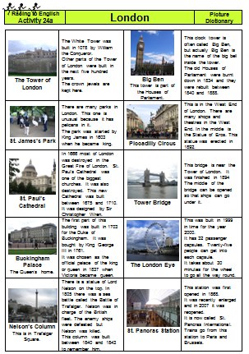  29a. London photoset | 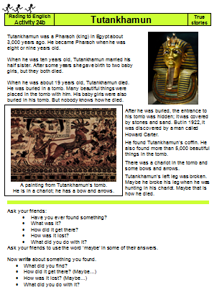  29b. Tutankhamun  true story | 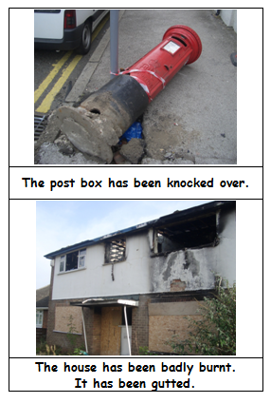  24e. Has been done
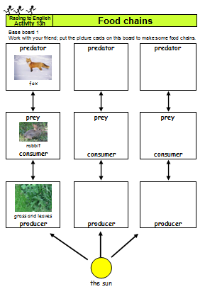  29e. Food chains | 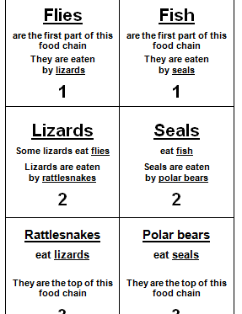  29f. Food chain rummy

True stories (3): could/would/when/vocab | Step | 30

Language learning focus
Language function | Narrating
Sentence structure | - Could you run when you were two?  - Einstein couldn't read very well, when he was young.  - What would you do if you found £25?  - If you live in a city it is difficult to see many stars.

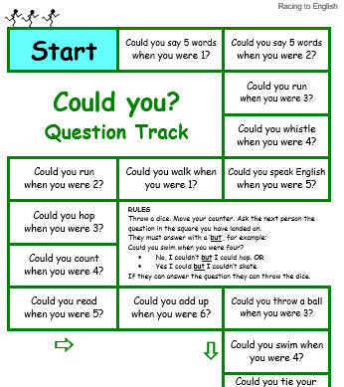  30a. Could you  question track | 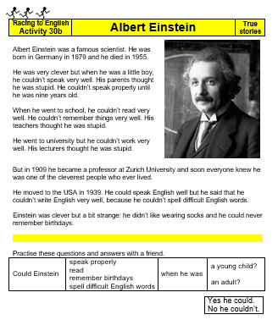  30b.  Albert Einstein  true story | 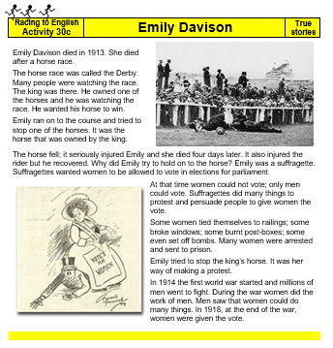  30c.  Emily Davison  true story
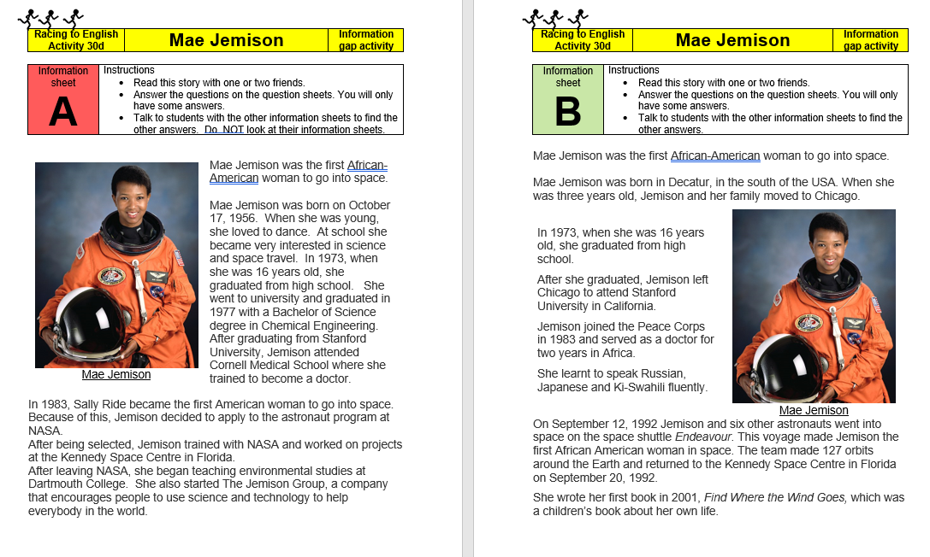  30d Mae Jamison – info gap |  | 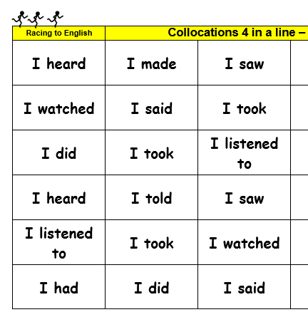  30v. Collocations 4 in a line  (Vocab development)

True stories (4): had done | Step | 31

Language Learning Focus
Language function | Narrating
Sentence structure | Past perfect tense and reported speech:  - They said that the helicopter had taken off at nine o'clock.  - Lenny had not told her he was going for an audition.

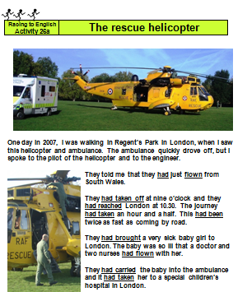  31a. The rescue helicopter | 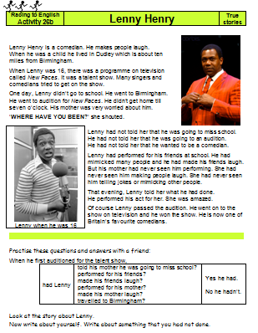  31b. Lenny Henry | 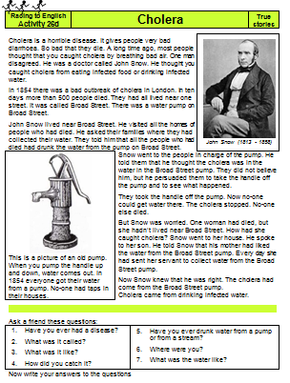  31c. Cholera | 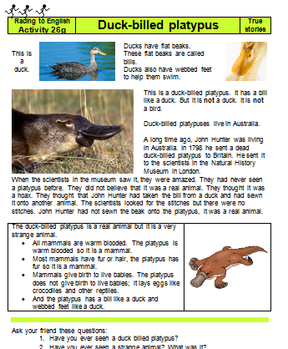  31d. Duck-billed platypus

True stories (5): Sun, seasons etc. | Step | 32

Language Learning Focus
Language function | Narrating
Sentence structure | This step and subsequent “true stories” are grouped around topics rather than tenses and they practise all the tenses that have been introduced earlier.

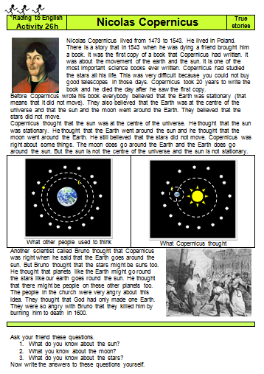  32a. Copernicus | 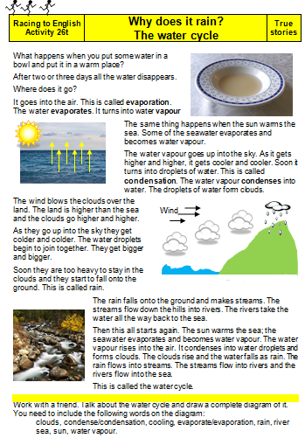  32b. Water cycle | 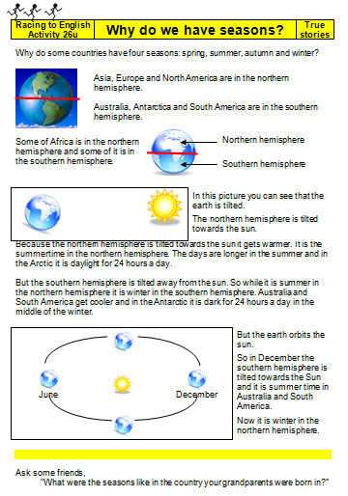  32c. Why do we have seasons? | 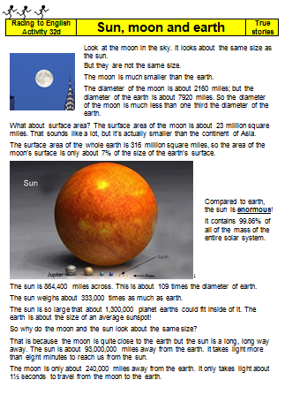  32d. Sun moon & earth

True stories (6): Animals, fossils & Darwin | Step | 33

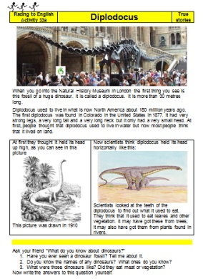  33a. Diplodocus | 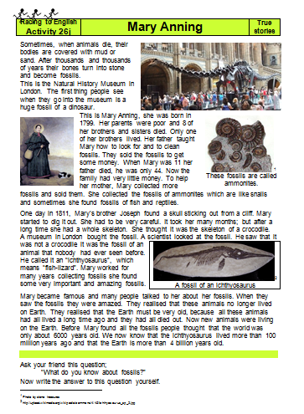  33b. Mary Anning | 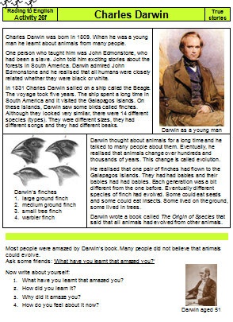  33c. Darwin | 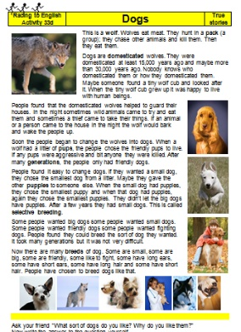  33d. Dogs
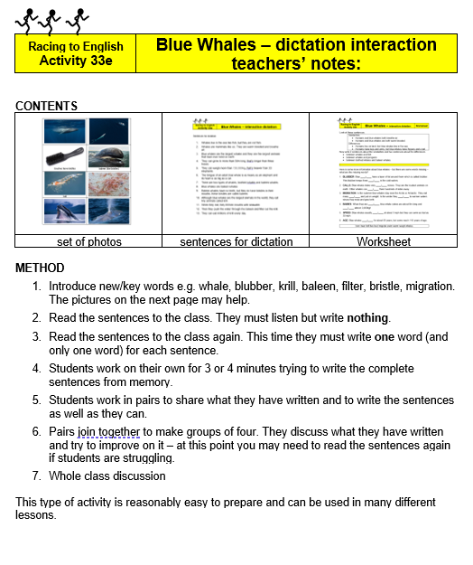  33e. Blue Whale | 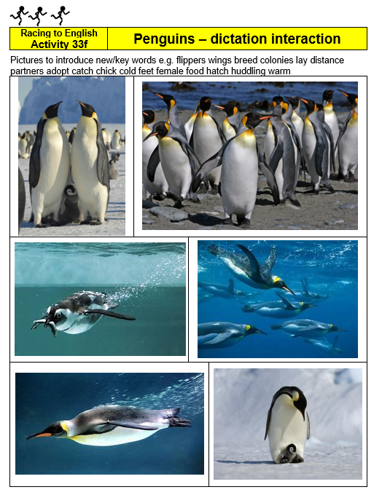  33f. Penguins | 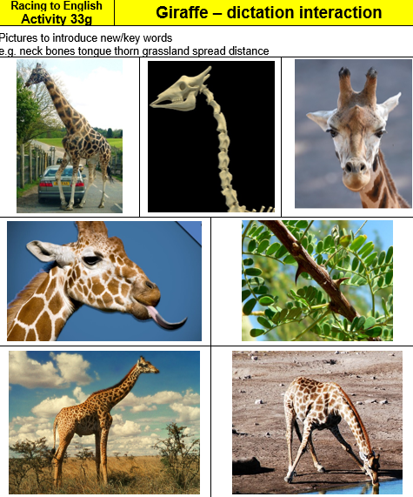  33g Giraffes | 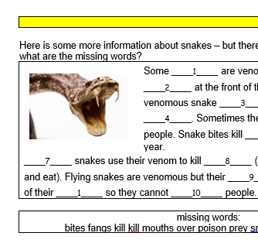  33h Flying snakes

True stories (7): Species & more fossils |  |  |  | Step | 34
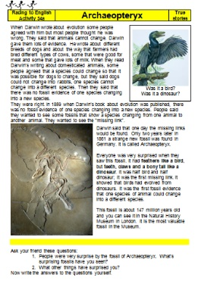  34a. Archaeopteryx | 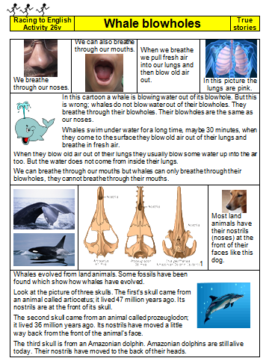  34b. Whale blowholes | 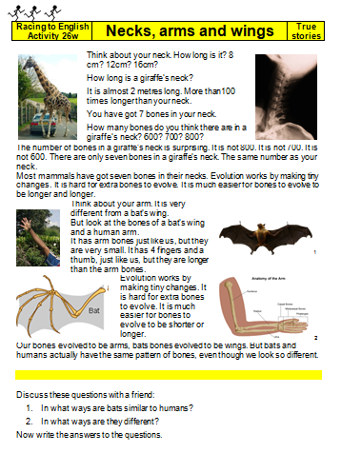  34c. Necks arms & wings | 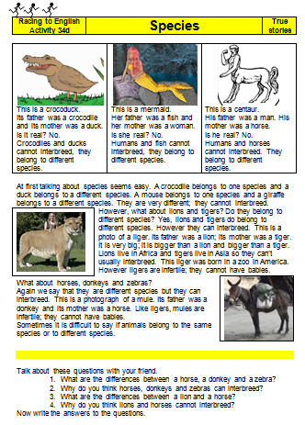  34d. Species 1
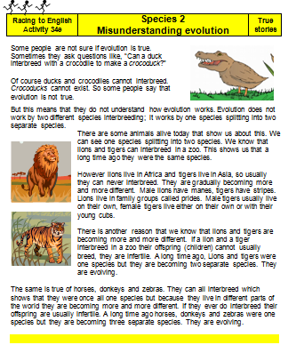  34e. Species 2 misunderstanding evolution | 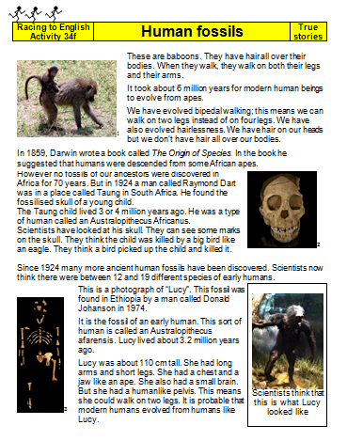  34f Human fossils

True stories (8): Geology |  |  | Step | 35
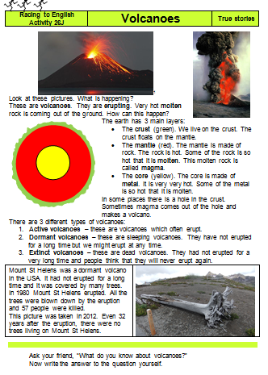  35a. Volcanoes | 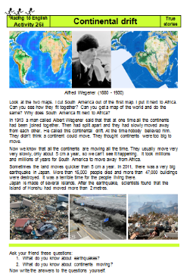  35b. Continental drift | 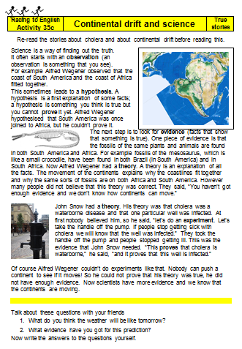  35c. Continental drift & science | 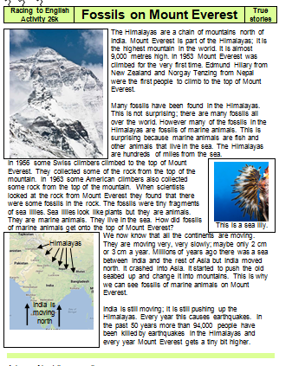  35d. Fossils on Everest
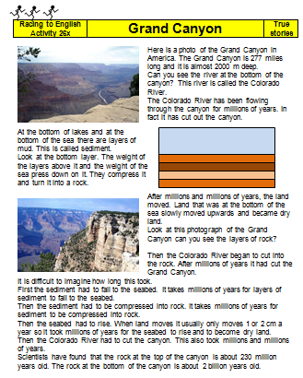
35e Grand Canyon

True stories (9): Deep time | Step | 36

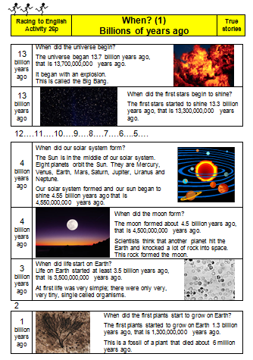  36a. When (1): Billions of years ago | 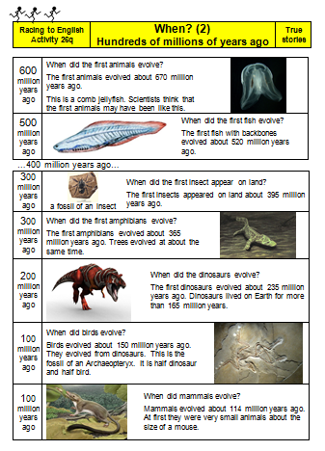  36b. When (2): Hundreds of millions of years ago | 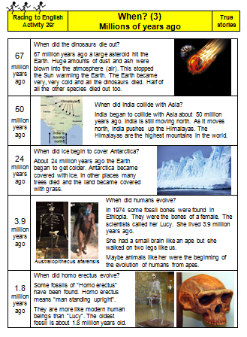  36c. When (3)  Millions of years ago | 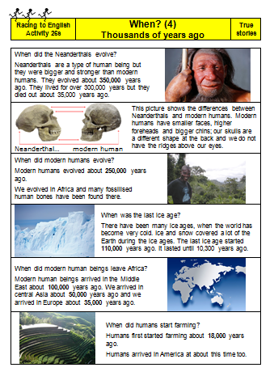  36d. When (4)  Thousands of years ago

If | Step | 37

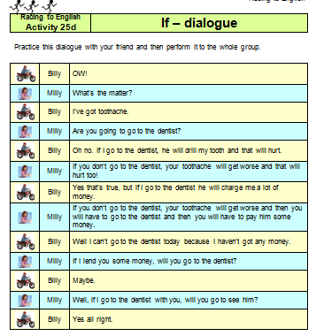  37a. “If” dialogue | 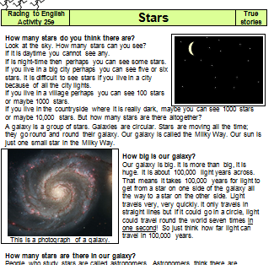  37b. Stars  true story | 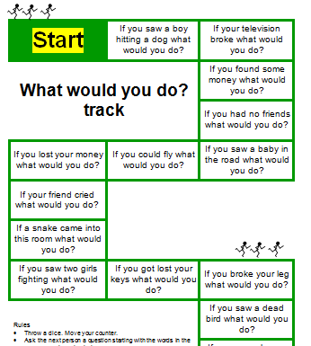  37c: What would you do? question track
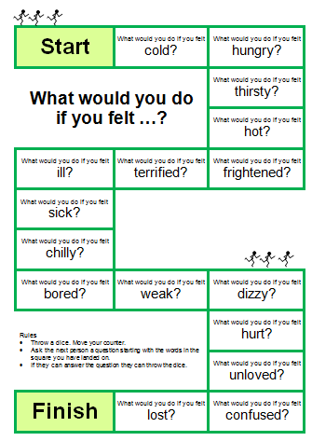  37d. What would you do if you felt | 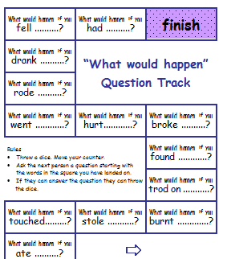  37e What would happen? question track | In this step there are also copies of:  - M5c UK money “If I had..  - M5c USA money “If I had  - M5L Time problems  - M5m “If” equations

Maps: Guess which country. | Step | 38

Language learning focus
Language function | Naming, defining and describing
Sentence structure | - It's a very dry area with very little rainfall.  - Is it north of the equator?  - Does it share a border with Nigeria?  - Is it on the Pacific coast? Has it got a coastline?
Examples of vocabulary that will arise from these activities | North  South  West  East | equator  coastline  border | mountain  stream  flood  desert | waterfall  canal  island  rainforest

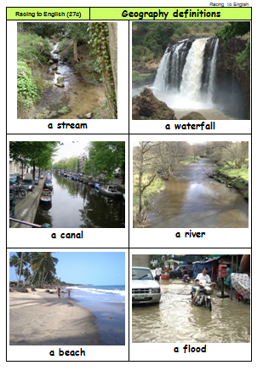  38a. Geography definitions | 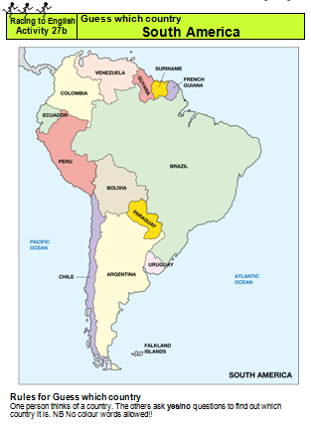  38b. Guess which country -- South America | 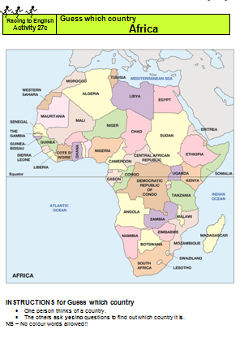  38c. Guess which country -- Africa
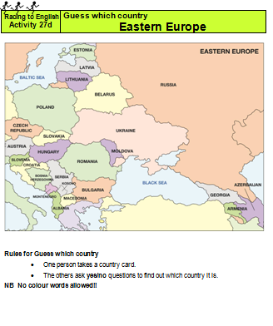  38d. Guess which country -- Eastern Europe | 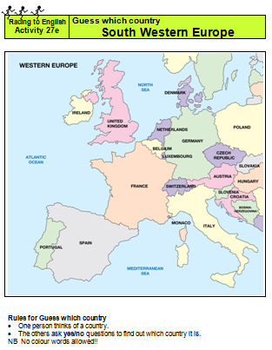  38e. Guess which country -- South Western Europe | 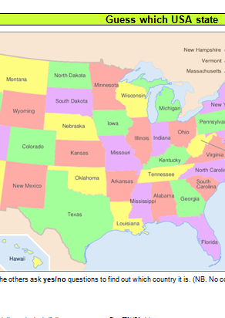  38f. Guess which state -- USA

Grammar tracks |  |  | Step | 39
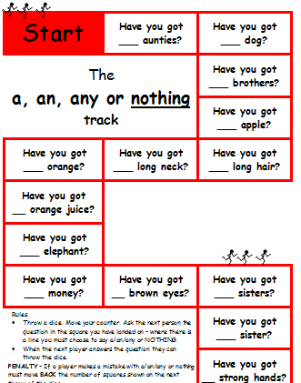  39a.  a/an/any/nothing | 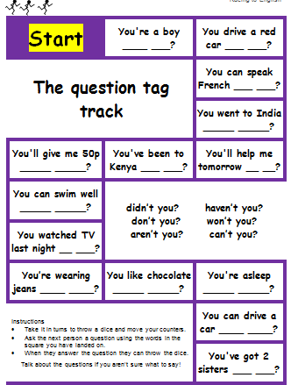  39b  question tags | 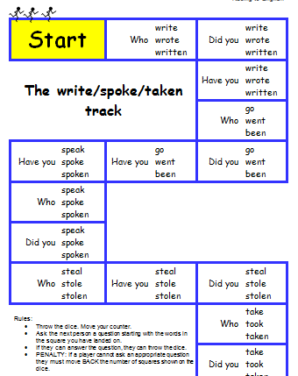  39c  write/spoke/taken | As well as these 3 new tracks, this step includes copies of about a dozen other tracks from all stages in Racing to English so that you can use them to revise and assess pupils progress conveniently.

Miscellaneous | Step | 40
As this step contains a miscellany of activities, there is no one overall main language focus. They are more advanced activities that didn't fit in with the other steps:
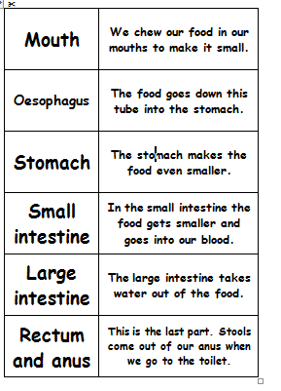  40a. Digestion rummy | 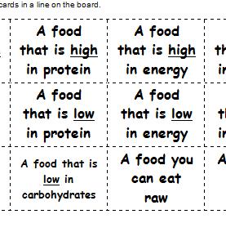  40b. Food  4 in a line | 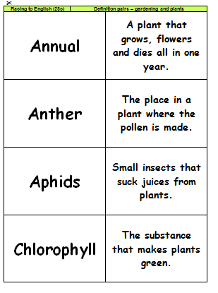  40c. Garden and plant pairs | 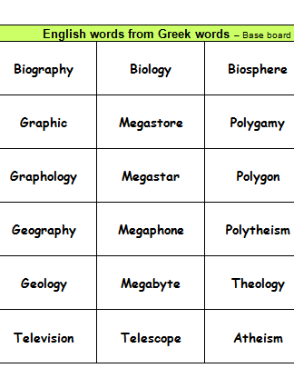  40d. Greek words  4 in a line
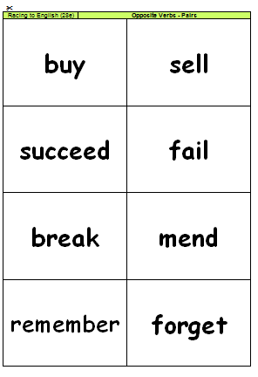  40e. Verbs  opposite pairs | 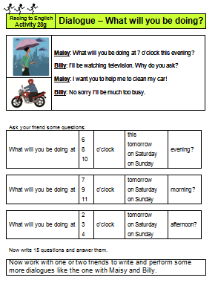  40f. Dialogue “What will you be doing? | 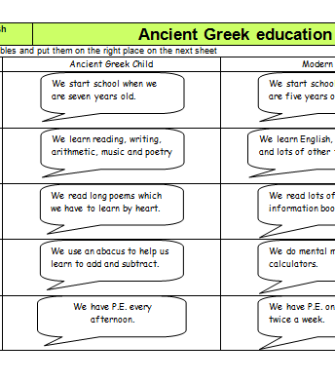  40g. Ancient Greek education

Maths 5 | Step | M5

This step contains a number of activities focusing on the language of maths.
Most of them are ‘Speaking Maths’ worksheets, including two versions of M4c (one based on British money, the other on American). Each worksheet focuses on keywords or phrases that are frequently used in maths problems.
Time problems is a quiz type activity.

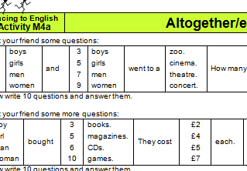  M5a. Altogether/each | M5b. Change | M5c  Money: If I had | 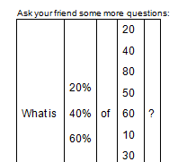  M5d Percentages
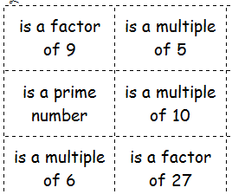  M5e Primes, factors and multiples 5 in a line | M5f  Posting parcels | M5g  Share equally | 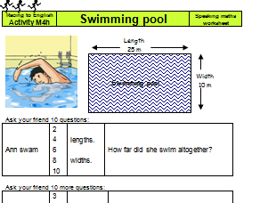  M5h  Swimming pool
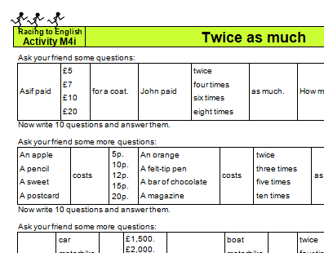  M5i  Twice as much | 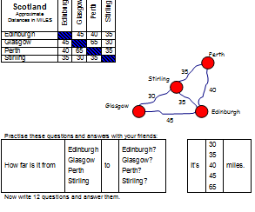  M5j  Distances UK | 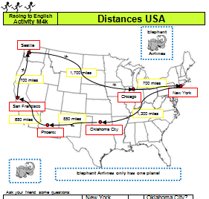  M5k  Distances USA | 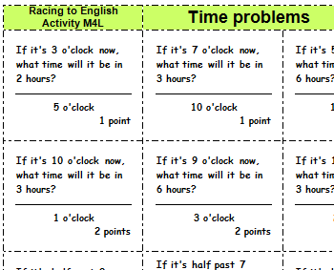  M5L  Time problems
M5m
“If” equations

